Task:. We have worked for the past several weeks on telling a story, we’ve learned various techniques to tell a story, and now it is time to use our imagination and remember back to our childhood. Your task is to create a children’s book with a lesson to be learned in language that a child would be entertained as well as informed.
Children’s Book Assignment
2) Rough Draft 3) Final Draft w/ illustrations. Specific instructions on criteria/requirements for assignment are located below…
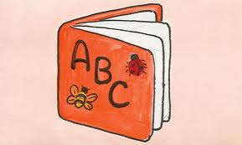
Criteria (requirements):
- The book must be 5 to 7 pages [ask for clarification]

- The assignment can be written (legible in blue or black ink) or typed using size 12pt Times New Roman font & double spaced.

- Each page must contain a minimum of 3 to 5 sentences to add to the story [1 paragraph]

- Story process must include a draft

- Story must have a “lesson learned” in it [preferably towards the end]

- Each page must have at least one illustration

- You MUST include a book cover with title & illustration.

- Story must have @ least one main character in your book.
- As well as @ least one supporting character

- Your illustrations should be your own. However, they do not have to be. You can use cutouts from magazines (provided by you), internet clips (provided by you), or any other means of illustration (perhaps collaboration).

- The pages will be all of a uniform size of your choosing (‘8 by ’11)

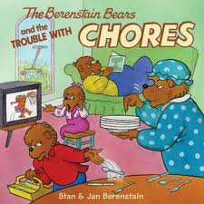
- Remember your audience (young children)

Value of Assignment: 50pts

