Unit 1- Test Review
Biology 113

- Define the following words:

  - mitosis - asexual reproduction where non reproductive cells divide and create 2 daughter cells with identical material as the parent cell

  - meiosis - sexual reproduction where gametes (sperm and eggs) divide and create 4 daughter cells with half the material as the parent cell

  - osmosis - the movement of water from areas of high concentration to low concentration

  - Diffusion - the movement of molecules from areas of high concentration to low concentration

  - Cells – the basic units of structure and function in living things

  - Gametes – the sex cells (sperm and egg)

  - Organ – tissues that work together to do a specific job

  - Organism – living thing

  - Organelles- small structures in the cytoplasm that have a special job to do

- State which cell (animal/plant/both) this structure is found in as well as its function:

- Cell Membrane – animal and plant – protects the cell, decides what moves in and out of the cell

- Cell Wall – plants only – gives the plant cell shape, supports and protects the plant cell

- Vacuole – animal and plant – “storage bins” store substances that will be used in the cell and holds wastes.

- Chloroplast – plants only – the green pigment in plants used in photosynthesis

- Nucleus – animal and plant – the “brain” controls the cell

- Nucleolus - animal and plant – located inside the nucleus and makes proteins

- Cytoplasm – animal and plant – all the living substance in the cell, the “jello” holds the organelles in place

- Centriole – animals only – the reproductive organs in animals

- Mitochondria – animal and plant – the “power houses” provide the energy for the cell

- Endoplasmic Reticulum – animal and plant – the “highway system” carries materials throughout the cell

- Ribosome – animal and plant – make proteins which help the cell grow and develop

- List the three parts to the cell theory.
  - All living things are made of cells
  - Cells are the basic units of structure and function in living things
  - Cells come only from other cells

- Given the following descriptions of microscopes place the correct name beside each description either: compound light microscope, transmission electron microscope (TEM) or Scanning Electron Microscope (SEM).
  - This microscope uses electrons to viewing 3D images of living OR non-living samples. SEM
  - This microscope uses light to view a sample at 2000x magnification. Compound Light
  - This microscope uses electrons to view images that must be non-living. TEM

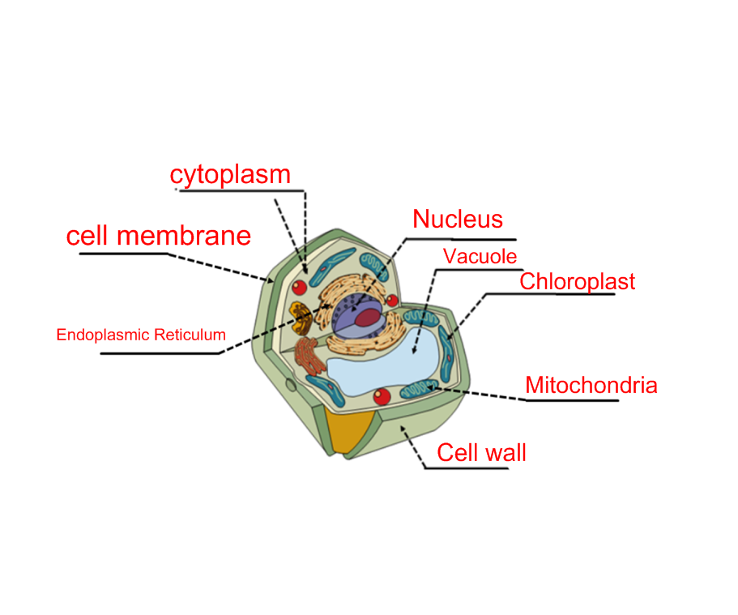
- Using the terms from question 2 above label the plant cell shown below:

- pg.72 Vocabulary Review (matching)
1. group of cells that work together to perform a specific job = organelles
2. Transport organelle = endoplasmic reticulum
3. group of organs that work together to perform a specific task = organ systems
4. separates the nucleus from the rest of the cell = nuclear membrane
5. makes up the largest part of a cell = cytoplasm
6. found only in animal cells = centriole
7. powerhouses of the cell = mitochondria
8. storage bin of a cell = vacuole

- pg. 72 Applying Definitions 1-6
1. diffusion, osmosis
Diffusion is the movement of molecules from areas of high concentration to low concentration, whereas osmosis is the movement of water from areas of high concentration to low concentration.

2. Mitosis, meiosis
Mitosis is the cell division of non reproductive cells. Meiosis is the cell division of reproductive cells. Mitosis results in two cells with identical chromosome numbers as the parent. Meiosis results in four cells with half the chromosome numbers as the parent.

3. cell wall, cell membrane
Cell wall is found only in plants and is the outside layer which protects the cell and gives the plant cell its shape. The Cell membrane is found in both plants and animals.

4. organ, organelle
An organ is a group of tissues that work together to do a specific job within your body. An organelle is a small structure within the cell that has a specific job.

5. nucleus, nucleolus
The nucleus acts as the control center in the cell, whereas the nucleolus is within the nucleus and functions in the production of proteins.

6. body cell, gamete
Body cells have 46 chromosomes each whereas gametes each have 23 chromosomes.

- pg 73. Content Review 1-4,6-8
1. True
2. True
3. Botanists study cells – Cytologists study cells
4. Ribosomes are the “storage bins” of the cell- Vacuoles are the “storage bins” of the cell
6. Meiosis results in two cells that have identical chromosomes – Mitosis results in two cells that have identical chromosomes
7. True
8. Cytologists believe mitochondria help to make proteins in the cell. – Cytologits believe ribosomes help to make proteins in the cell.

- pg. 73 Concept Review 1-5
1. What is the outermost structure of a plant cell?
Cell Wall
2. What is the outermost structure of an animal cell?
Cell Membrane
3. what differences exist between the vacuoles of plant and animal cells?
Plant cells have one large vacuole compared to animal cells which have several smaller vacuoles.
4. What structures do plant cells have that animal cells do not have?
Cell wall, chloroplasts
5. What structures do animal cells have that plant cells do not have?
Centrioles

