MNN.com

6 reasons to make your bed every morning

This simple chore can lead to happiness and better sleep, so why not give it a shot?
By: Laura Moss
August 20, 2015, 10:02 a.m.
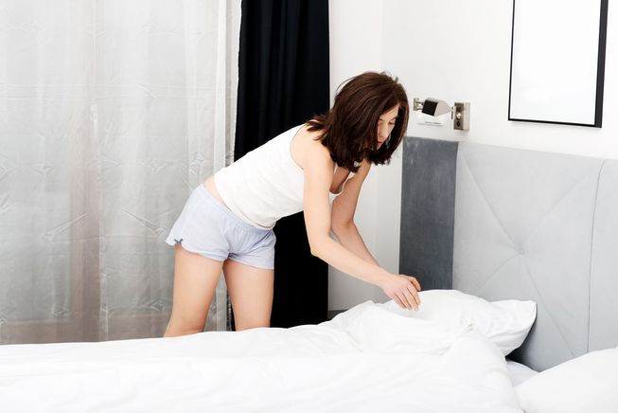

It may be a chore, but making the bed won't take long and the payoff is worth it. (Photo: Piotr Marcinski/Shutterstock)
Last year, Naval Adm. William H. McRaven — the man who commanded the SEAL team that hunted for Osama bin Laden — gave University of Texas graduates some unusual advice during his commencement speech: If you want to change the world, start by making your bed.
He acknowledges that this statement may seem “a little ridiculous,” but says, “the wisdom of this simple act has been proven to [him] many times over.”
Indeed, while making the bed may take just a minute or two each morning, the payoff is long-lasting and surprisingly far-reaching.
So if making your mother proud isn’t motivation enough to get you to smooth the sheets and fluff the pillows, maybe these reasons will be.
1. It helps you start the day off right.
Completing the simple chore of making your bed can be the start of a productive day.
“If you make your bed every morning, you will have accomplished the first task of the day,” says McRaven. “It will give you a small sense of pride, and it will encourage you to do another task and another and another. By the end of the day, that one task completed will have turned into many tasks completed.”
2. Happy people make their beds.
In a survey of 68,000 people by Hunch.com, 71 percent of bed-makers consider themselves to be happy people while 62 percent of non-bed-makers say they’re unhappy. According to the survey, bed-makers are also more likely to own a home, like their jobs, and exercise regularly.
“When I’ve asked people what happiness-project resolution has made a big difference in their happiness, many people cite the modest ‘Make your bed,’” writes Gretchen Rubin, author of the bestselling book "The Happiness Project.”
3. You’ll sleep better.
A National Sleep Foundation survey found that people who make their beds every day or almost every day were 19 percent more likely to report getting a good night’s sleep than those who don’t make their beds.
4. It helps establish good habits.
In his book, “The Power of Habit,” Charles Duhigg writes, “Making your bed every morning is correlated with better productivity, a greater sense of well-being, and stronger skills at sticking with a budget. It’s not that a family meal or a tidy bed causes better grades or less frivolous spending. But somehow those initial shifts start chain reactions that help other good habits take hold.”
5. It can reduce stress.
Living in a cluttered, messy space causes stress, which is why Marie Kondo, bestselling author of “The Life-Changing Magic of Tidying Up,” makes the argument that keeping your physical space in order can help you put your mental space in order as well.
"When you put your house in order, you put your affairs and your past in order too,” she writes.
6. It just feels good.
While it may be a chore to make the bed, sleeping in a freshly made bed tops the list of things that make us feel good, according to a survey of 2,000 people by Bupa.

Questions for Critical Thinking:

- Were you surprised by the advice offered to the University of Texas graduates by Naval Adm. William H. McRaven? Why or why not? (Analysis/Evaluation)

- Of the six reasons provided in the article for making your bed, which one is the most convincing for you? Explain why you’ve made this selection. (Evaluation)

