How Businesses Use Your Digital Footprint
Information is power. In the marketing world, information about customers can give a company the power to succeed in a competitive economy. Companies gather information on customers in every way possible, including:
- Point of sale
Information collected during an actual sale (point of sale) is particularly valuable. Companies collect and save any information they can about who makes a purchase; when, where, during what sale, and with what other items was the item purchased; and what points card or coupon was used.
- Loyalty programs
The easiest way for a company to collect information on who you are, as well as your shopping habits and preferences, is for you to give it to them. You do this when you sign up for a store's points card or other loyalty program. For a small bonus or other incentive, you show your card each time to make a purchase in the store, and that business can record your shopping history.
- Surveys
People love surveys, particularly when they might win a prize or receive a coupon for completing them. Businesses collect valuable information about their own operations and their customers when we complete paper or online surveys about our interests, a recent purchase or our satisfaction with the service we receive.
- Cookies
Cookies (or HTTP cookies) are small amounts of data that are loaded onto your computer when you first visit a website. The cookie stores information about your settings and activities that relate to that site. For example, a cookie might record the date when you first visit; the name, address and password you use to register; settings you select for the site; buttons you click and pages you visit. When you return to the website, the cookie provides this information so the website can respond to your particular activity, preferences, interests or needs. Cookies enable a website to "remember" you.

Watch the following video to learn how advertisers use cookies to track you:
http://www.wsj.com/video/how-advertisers-use-internet-cookies-to-track-you/92E525EB-9E4A-4399-817D-8C4E6EF68F93.html#!92E525EB-9E4A-4399-817D-8C4E6EF68F93

Much of the information we provide companies is part of our digital footprint. Some of that data is stored in a company's own computers, and some is collected and stored by businesses that focus only on collecting consumer data. Even more information is saved by companies that choose to rent out or sell the customer data they gather for their main business, in order to earn extra revenue.
The result is that businesses may have access to vast amounts of data—far too much for them to easily sort through and use in the form in which it is stored. This is called raw data. For example, a piece of raw data might tell that a blue bamboo-fibre t-shirt was sold for $12.99 on February 15 to Tim Lee, who is 18 years old. On its own, raw data is not very useful.
To make use of the vast amount of data available, it has to be turned into useful information. Data mining software "mines" raw data to create information—to identify trends and patterns in the raw data. By examining all the data collected by a chain of stores selling that blue t-shirt, data mining software might produce information like:
- T-shirt sales increase in mid-February, just before March Break.
- Blue t-shirts are the least popular colour this year.
- Eighteen-year-old males are buying more t-shirts this year than they did over the past 10 years.
- Seventy-eight percent of people buying this brand of t-shirt in February used an online coupon.
- Bamboo fibre is more popular among 18-year-old males than cotton or polyester-cotton blends.
When data mining can identify buying patterns based on data such as age, income level, educational background, cell phone number and address, then its information can be used to target mail-out packages to the addresses of people who are most likely to make a purchase, and target electronic ads to devices used by the most likely customers

Your mobile device can also help advertisers target specific ads directly to you. Communication between smart signs or other advertising devices, and cookies on your smart phone enable these signs to display ads for products you like, or advertising devices to play audio addressing your interests as you pass by. Products or songs you liked on Facebook, purchases you made online and websites you visited can all be used to deliver ads selected to match your interests, without you being involved or aware.
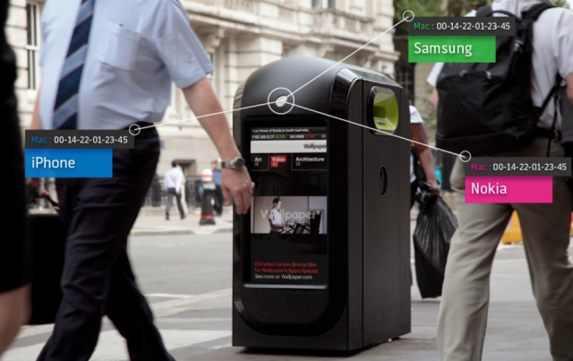
Click on the picture above to read how Target used data mining to tell that a high school student was pregnant (and send her maternity related coupons) before her father knew.
Click on the picture above to read how this type of tracking and advertising was used in London during the 2012 Olympics.

