- THOUGHTFULLY PROVIDE NOTATION ON THIS ARTICLE TO SHOW EVIDENCE OF YOUR THINKING THROUGHOUT YOUR READING (text-to-self, text-to-text, text-to-world, and vocab strategies).
- RESPOND TO THE “Food for Thought” SECTION BELOW THE ARTICLE.

Artist Khaled Akil imagines Pokémon Go in ravaged Syria

Khaled Akil's project showing fun characters amid woeful scenes is a reminder that war goes on as the world turns away.

Anealla Safdar, AlJazeera.com, July 22, 2016

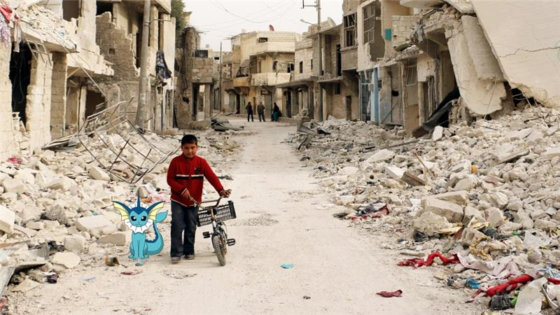

As his home city of Aleppo continued to wane at the hands of the five-year-civil war, Khaled Akil wondered what it would be like to hunt for the Pokémon characters amid the rubble in Syria.
In the Syrian artist's latest project, a series of photos from AFP posted to his website show the catchable monsters amid scenes of despair.
The project is titled, "Pokémon Go In Syria - Part 1". The result is eerie.
The animated figures watch on in the aftermath of a bomb blast; stare into the camera as a child walks between crumbled buildings; creep out from a burst pipe as young boys swim in dirty water and squat atop a tank with fighters from the Islamic State of Iraq and the Levant (ISIL, also known as ISIS) group.
"Being an avid follower of news and global social trends, I found this unnerving contradiction between the playfulness of the Pokémon world and the danger which Syrians and Syrian children live through every day," he told Al Jazeera.
"I wondered what it would be like to hunt for a Pokémon character among the rubble in Syria, and how a virtual game attracts more attention than the atrocities committed daily in real-life Syria."
The artwork, he added, is not meant to point fingers but rather highlight the crisis.
"This project is not to blame people for not paying attention for Syria at all, it is just a spotlight on what is happening there."
Born in Aleppo, 30-year-old Akil travelled to Istanbul in 2012 to attend a solo art exhibition, but was forced to stay in the Turkish city as the war at home escalated.
Many of his family members still live in Syria and refuse to leave.
"They are there on the hope that the war will someday end and they will be there to welcome us, the ones who fled," he said.
Like millions of others of Syrians, he has one simple dream: that the streets of his home city are peaceful once again.
"While the [Pokémon] game is largely successful, I truly wish I can stroll down the streets of Aleppo without a phone or a Pokemon, just me and the once-beautiful city," he said.
The Syrian civil war has claimed more than 250,000 lives and displaced millions, with most taking refuge in Turkey, Lebanon and Jordan.

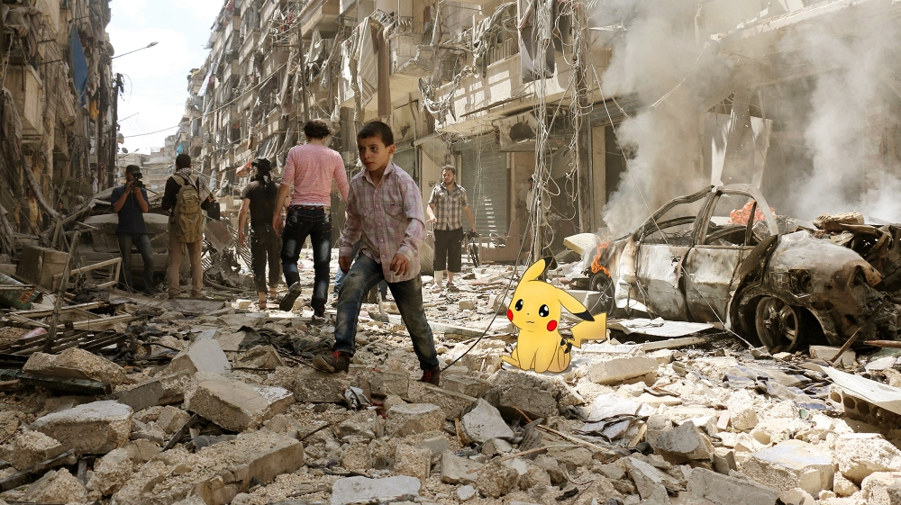

Food for Thought (Choose EITHER Appropriate (#1)OR Strong (#s 2-3):

Appropriate level:

1. Before reading this article, did you know more about Pokemon Go, or about the conflict in Syria?

a) Brainstorm what you knew about each on the T-Chart below (applying):

What I knew about Pokemon Go What I knew about Syria

b) Is it true that more people in North America know about Pokemon Go than about the war in Syria? Why would this happen (analyzing)?

c) Based on what you have seen and read in this article, think of the best word to describe the conditions in Aleppo, Syria (understanding):

(Strong level)
2) Have another look at the last sentence from the bottom of page 1. Consider the highlighted words like avid, global social trends, and unnerving contradiction.
a) Describe the strategy you use when you come across words you don’t know (analyzing):

b) Then, give your strategy a try by guessing what the following words and phrases might mean:
Avid:

Global social trends:

Unnerving contradiction:

3) a) What was the artist’s ultimate goal in developing these art pieces (understanding/ analyzing)?

b) Was he successful? Explain (evaluating/ applying).

