Let’s Get Introduced to Another Culture . . .

The Merriam-Webster Dictionary defines the word Culture in the following ways:
- the beliefs, customs, arts, etc., of a particular society, group, place, or time
- a particular society that has its own beliefs, ways of life, art, etc.
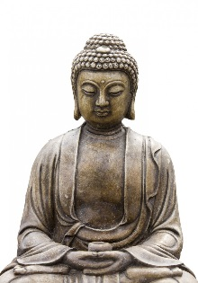
- a way of thinking, behaving, or working that exists in a place or organization (such as a business)
The list below outlines the seven elements of culture:
- Social Organization
- Customs and Traditions
- Religion
- Language
- Arts and Literature
- Foods
- Forms of Government
- Economic Systems

It is always interesting to observe other cultures to see how they do things differently than ourselves. Alone, with a partner, or in a group of three, you will determine an aspect(s) of another culture you would be interested in knowing more about. You will then conduct research to gather as much information as you can.

Here is the Twist:
You will then take the information you’ve acquired and prepare a PowerPoint presentation suitable to teach a class of grade three students about your cultural aspect(s). This means that although the information should be thorough, it should be presented at a grade three level and in a manner that would be enjoyable to children of that grade level. In addition to your PowerPoint presentation, you may (and are strongly encouraged to) incorporate other elements into your lesson such as video clips, music, props, food samples, etc. Use your imagination!

Some Tips on Research Skills:
Do multiple searches and try using only those sites that have an author and date updated. This helps ensure accuracy and creditability. Don’t use other students’ blogs or random sites that may be inaccurate. Keep track of your site details as you will be responsible to build a works cited page.

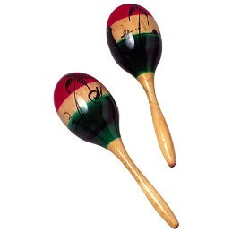
You will be evaluated on the following criteria:
Your ability to effectively research 20
Your ability to work productively alone or as a member of a group 20
Your ability to effectively present your information to the class 20
Your ability to present your information at a grade three level 20
The creativity and thoroughness of your project 20

_________

Value: 100 Marks

Please Note: If you are absent from class three days during this project, you will be responsible for completing a project on your own, since you will not truly be contributing to the work of your group.

