Physics 112 Final Exam Review Multiple Choice
- Which of the following is a scalar quantity?
  - Displacement b. distance c. force d. acceleration

- A group of bike riders took a 4.0 hour trip. During the first 3.0 hours they traveled a total of 50 kilometers, but during the last hour they traveled only 10 kilometers. What was the group’s average speed for the entire trip?
  - 15km/h b. 30km/h c. 40km/h d. 60km/h

- A car accelerates uniformly from rest to a speed of 10 meters per second in 2 seconds. The acceleration of the car is:
  - 0.2m/s² b. 5m/s² c. 10m/s² d. 20m/s²

- An object starting from rest accelerates at a rate of 3.0 m/s² for 6.0 seconds. The velocity of the object at the end of this time is:
  - 0.50m/s b. 2.0m/s c. 3.0m/s d. 18m/s

- An object near the surface of planet X falls freely from rest and reaches a speed of 12.0 m/s after it has fallen 14.4 meters. What is the acceleration due to gravity on planet X?
  - 2.50m/s² b. 5.00m/s² c. 9.80m/s² d. 10.0m/s²

- A clam dropped by a sea gull takes 3.0 seconds to hit the ground. What is the sea gull’s approximate height above the ground at the time the clam was dropped?
  - 15m b. 30m c. 45m d. 90m

- A boat initially traveling at 10 meters per second accelerates uniformly at the rate of 5.0 meters per second squared for 10 seconds. How far does the boat travel during this time?
  - 50m b. 250m c. 350m d. 500m

- If an unbalanced force of 12 newtons acts on a 6 kilogram mass, the acceleration of the mass is:
  - 0.5m/s² b. 2m/s² c. 10m/s² d. 72m/s²

- As the unbalanced force exerted on an object is increased, the objects acceleration will:
  - Decrease b. increase c. remain the same

- Which unbalanced force acting on 4.0 kilogram object will produce an acceleration of 8.0m/s²
  - 32 newtons b. 2.0 netwons c. 0.50 newtons d. 4 newtons

- An unbalanced force of 2 newtons applied to a given mass produces an acceleration. If an unbalanced force of 1 newton is applied to the same mass, the acceleration produced will be:
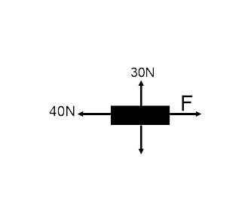
  - The same b. twice as much c. one half as much d. four times as much

- Four forces are acting on an object as shown in the diagram. If the object is moving with a constant velocity, the magnitude of the force F must be:
  - 0N b. 20N c. 100N d. 40N

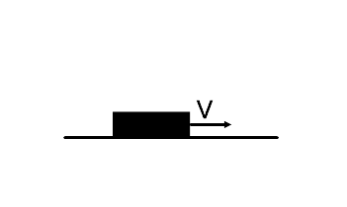
- A box decelerates as it moves to the right along a horizontal surface, as shown in the diagram. Which vector best represents the force of friction on the box?
  - b. c. d.

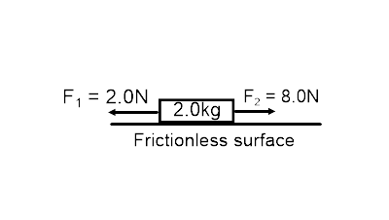
- Two forces are applied to a 2.0 kilogram block on a frictionless, horizontal surface, as shown in the diagram below. That acceleration of the block is:
  - 5.0m/s² [E] b. 5.0m/s² [W] c. 3.0m/s² [E] d. 3.0m/s² [W]

- A 3.0 kilogram mass weighs 15 newtons at a given point in the Earth’s gravitational field. What is the magnitude of the acceleration due to gravity at this point?
  - 45m/s² b. 9.8m.s² c. 5.0m/s² d. 0.20m/s²

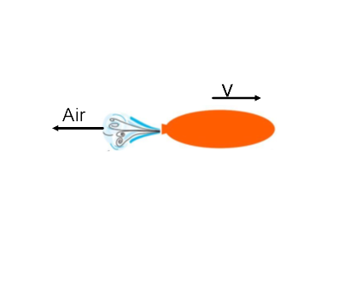
- As shown in the diagram, an inflated balloon released from rest moves horizontally with a velocity v. The velocity of the balloon is most likely caused by:
  - Action-reaction b. centripetal force c. gravitational attraction d. rolling friction

