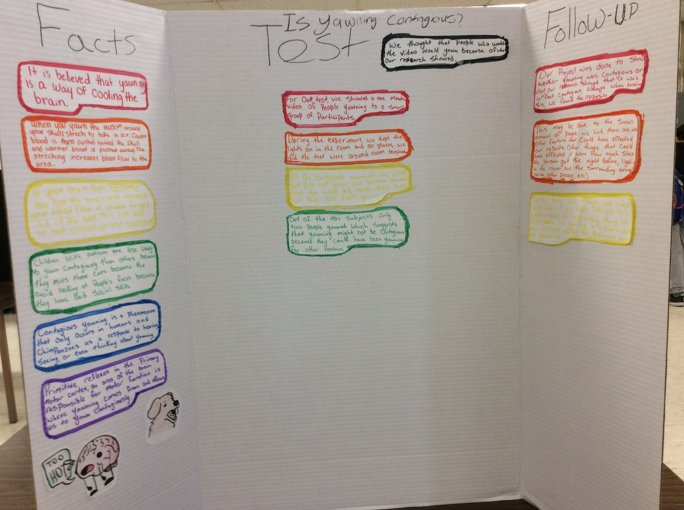Phycology Journal
Shelbie Donald
For our project I learned why we yawn. It is believed that the reason we yawn is to cool the brain which is not what I had thought at all, when I think of yawning I usually don’t think of the temperature in a room. When I think of yawning I think of being board or tired so I was surprised to find that it may be because of temperature. I also learned that if people know what you’re trying to do, they won’t do it. For my tests I showed the participants a video of people yawning and most of them easily clued into what I was doing and did the exact opposite. I also learned that autism will effect whether someone contagiously yawns or not. This is because people with autism have some trouble with social skills and will make less eye contact than the average person, because of this they will miss some of the yawning ques and they won’t contagiously yawn as much.
When looking at other projects I learned that adults are less afraid of death than younger people. I feel like adults just stop caring about that after a while because it’s not something we can stop from happening. At some point in time they would probably stop fearing it as much as when they were younger. I also learned that we will do risky things because of pleasure. Everyone wants to be happy and feel pleasure and because of this some people will do risky things in order to achieve this.
For the proses of our project I learned that I need to get better at time management because we were in a bit of a rush to get our project done near the end. I think I also learned how to pick out information that went with the project and that didn’t go with what we were studying.

Kayla McFarlane
Journal
My project was about how and why yawning is contagious. I learned that contagious yawning only occurs in humans and chimpanzees as a response to hearing, seeing or just thinking about yawning. Children with autism are less likely to yawn because of their lack of social skills. Age was the most important predictor of contagious yawning and I think that affected our test results. One interesting fact that stuck out to me was that yawning has many triggers, some are boredom, sleepiness and temperature. As cold temperature enters the body or goes down near freezing, we yawn less. We may yawn to regulate the temperature of our brains, yawning might act to draw brain soothing ambient air in through the nose and mouth. When you yawn contagiously it happens because you just can’t help it. If you become self-conscious about a yawn it stops. When I researched about ages and how your age could affect if you yawn contagiously or not I found that people with autism or schizophrenia don’t yawn contagiously, the same is true of children under the age of 4 years old. Parts of the amygdala a brain area associated with fear and attention light up in response to images of yawning, we sometimes yawn when we’re nervous. People thought that contagious yawning could be a smart shortcut for readying the brains for an action in response to a threat, this may have helped groups to survive. I noticed that many people believe they found the solution to why yawning is contagious but there really is no way to really tell if it is, but to me, I don’t really think it is. Hundreds of different people give different reasons that are either hard to believe or just don’t make sense. The temperature of the room you’re in, the lighting or even the way we feel can affect our yawns and it doesn’t really make sense that other people control them as well. The process of working on this project was a little hard for me, if found that it was hard to get things done in time because of after school activities and trying to get the whole group together at once. I think I need to work on my time management along with working better in a group because I found myself not doing as much work as I should have.
Matthew Blakley
Journal
Contagious yawning is triggered involuntarily when we observe another person yawn when doing our project, I learned that yawning is a sign of empathy, tiredness and boredom, it can also be a way to cool the brain as the muscles stretch but when we did our test we found out that only two out of ten people yawned and they could have yawned for other reasons like if the amount of sunlight in the room effected them, the environment they were in or the age group, it also could have been affected by how close the people were to family or if they were just random people. I also learned that contagious yawning can affect chimpanzees, dogs, cats, birds and also reptiles. People are more likely to yawn during the winter, the average yawn last approximately 6 seconds. Some evidence suggests that yawning is a means of communicating changing environmental or internal body conditions to others. Contagious yawning is less common in people with autism because they lack the social skills to look at people’s faces

