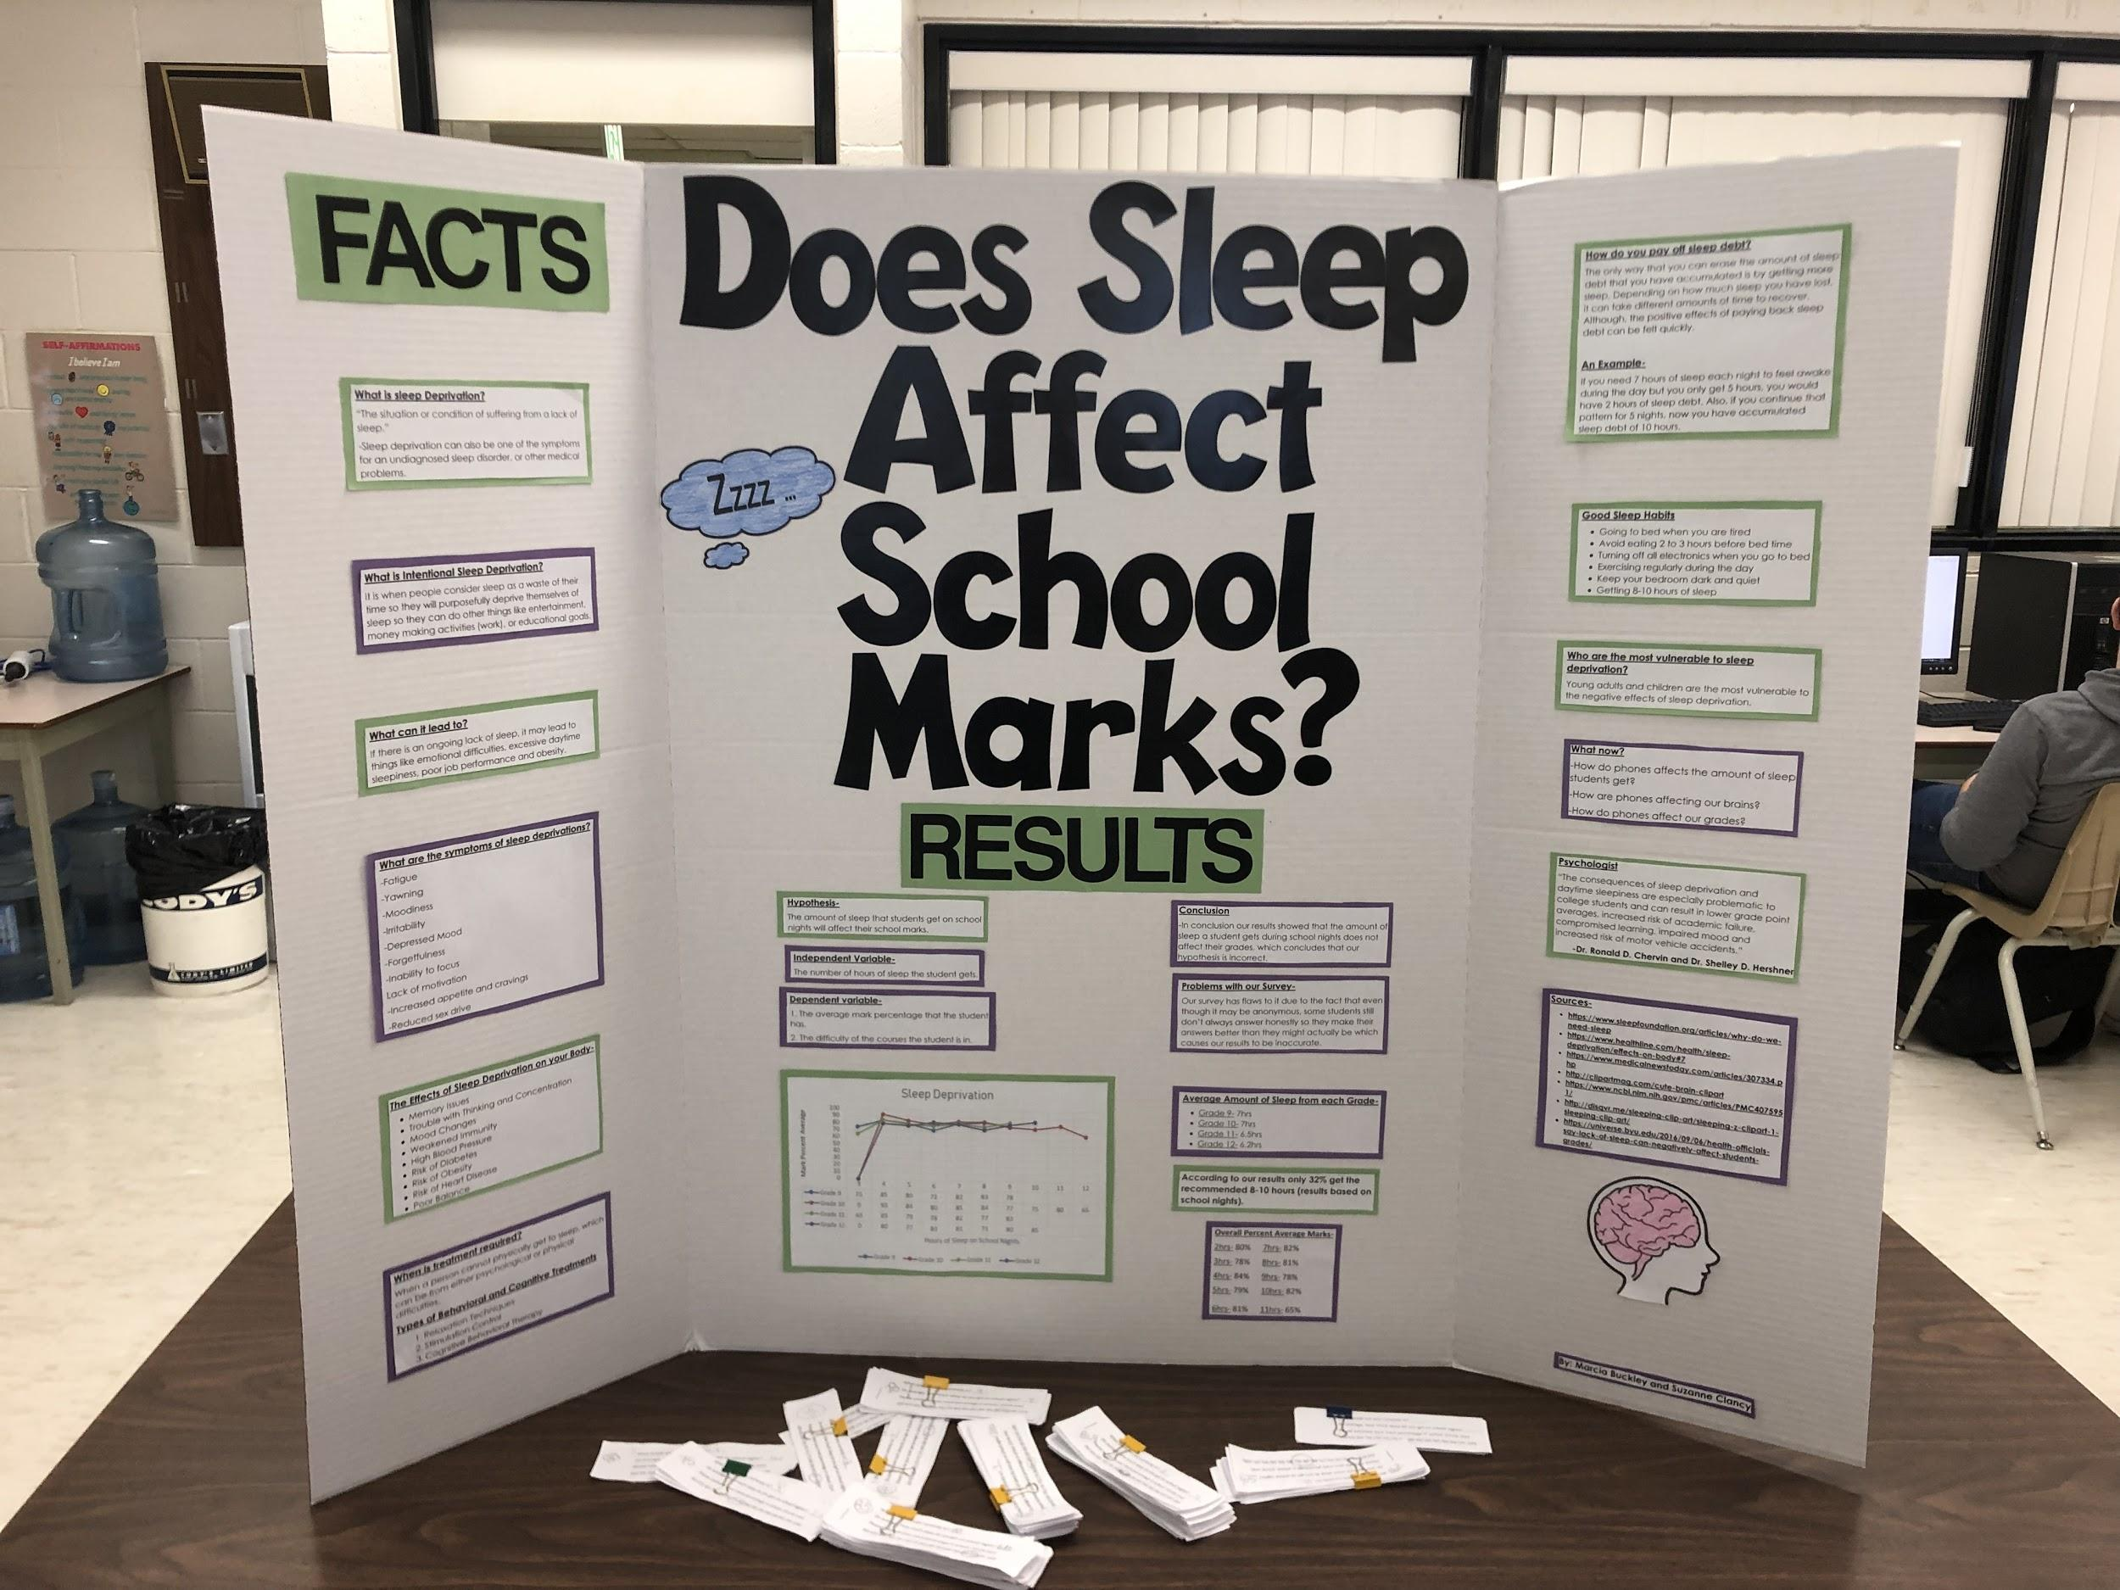Marcia Buckley
Psychology 120
Does the amount of sleep students get
on school nights affect their school marks?
After completing this project I learned about the importance of sleep and the many ways that it can affect your body. I had always known that getting the suggested amount of sleep was very important but after doing the large amount of research that was required for this project it opened my eyes up to the fact that if you do not sleep for a certain amount of days that you can actually die. For our project we surveyed 234 people from our school and asked them what grade they were in, on average how many hours of sleep they get on a school night and what their average percentage mark is in school. Based on our research we believed that the amount of sleep would in fact affect their school marks; but our results from the survey proved that to be wrong. Although we realize that our survey has flaws to it due to the fact that even though it was anonymous people still feel the need to put their amount of sleep or average mark higher than they actually are because they don’t want people to know the truth. The information that I learned about what sleep does to your body and how your risk for health problem raises a lot when you have sleep deprivation is honestly terrifying. I believe there is no doubt that if the teenagers that do not get 8-10 hours of sleep each night would question whether or not they want to risk having all those different health problems too.
One thing that I found very interesting about sleep deprivation is that if it becomes chronic enough it can actually lead to anxiety or depression. This makes sense because if you suffer with anxiety or depression already chances are you are suffering from a lack of sleep which can lead to sleep deprivation so they go hand in hand.
Sleep is such a large part of our lives and people don’t realize how much better they would feel and students would see such an improvement in their grades too if they got the recommended hours of sleep for a grade. You can give them all the information and facts but it will always be up to themselves if they want to make that change in their live.
Suzanne Clancy
Psychology 120
Does the amount of sleep you get affect their average marks in school?
Doing this project I actually learned many new things about sleep. I learned that teenagers need 8-10 hours of sleep, but most don’t get that recommended amount. Kids need more hours of sleep than any age category because they’re growing and their brains need that extra time to develop. I also learned that kids and adults are the two age categories that are more sleep deprived and are more likely to suffer from it. I found out that not getting enough sleep can increase your chances of getting type 2 diabetes, it can cause you to gain weight because you’re brain isn’t getting the right information and rest it needs to tell your body your full, so it makes you to continue to eat and it also makes you crave food that aren’t as healthy for you. It can also cause you to become more moody, you can become more prone to common colds and flu because when you don’t sleep enough your body isn’t getting the rest it needs to fight the cold and flu so it can also take more time for you to get better. When you sleep your body protects, retains new information, it makes sure everything is functioning right and it also makes you able to learn new things. I also learned that there are problems when doing surveys. People lie on surveys for different reasons, some of which are to show off or because of fear or trying to please others or because they do not understand the purpose of the surveys. I also learned that sleep dept. is the amount of sleep a night you aren’t getting that you should be getting, for example if you get 5 hours of sleep a night but you should be getting 7, your hours of sleep dept. would be 2 hours, if you’d continue only getting 5 hours a night for 5 days, your sleep dept. would be 10 hours. It is possible to get rid of that sleep dept. by sleeping an extra 10 hours. Even if you do sleep off the sleep dept., the effects won’t be as good as if you just slept that 7 hours to begin with. I learned that sleep deprivation can be because of medical problem, undiagnosed sleep disorder or maybe because you work late at night and you have to get less sleep than you should be getting because of your job, or maybe you have a test the next day and your trying to study all that material the day before. Studying the night before and not getting enough sleep won’t actually help you study because your memory is affected if you don’t get enough sleep.

