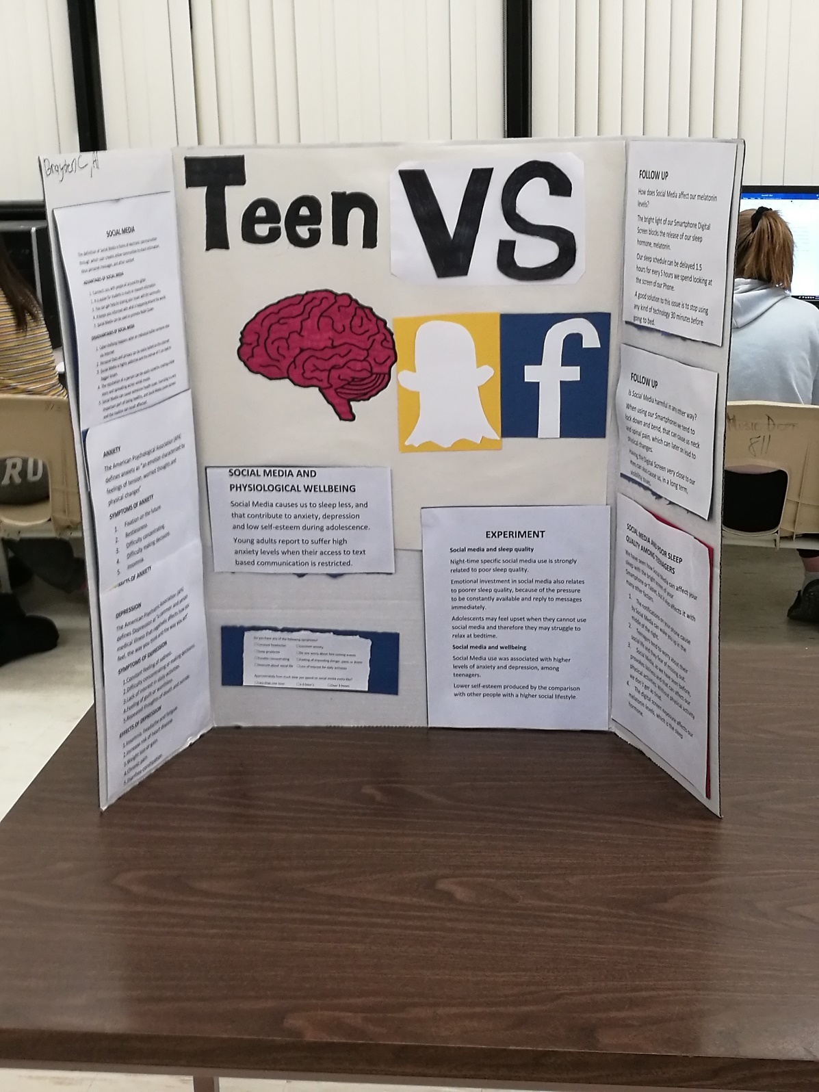

EFFECTS OF SOCIAL MEDIA IN A TEEN’S BRAIN
While doing this project I didn’t just learn about the relation between and social media, but also about how to collect information in a more effective way.
For this project, I tried doing something different than just typing in Google the keywords, and reading the entire Wikipedia, this time I have actually been reading other people studies about this subject, and used that information.
About the actual project and its content, I came up with the idea that social media will never affect your wellbeing directly. What I mean is that not because you like a post in Instagram something bad is going to happen to you, but the overuse of this tool may cause you Anxiety or Depression, which can lead to headache, sleep deprivation, etcetera. Those three examples, I’ve used previously are really common but also very dangerous mental issues that can injure your brain permanently if they are not treated properly.
Another way Social Media can affect you in a non-direct way is through your Smartphone or tablet. The bright light displayed by the Digital Screen can affect your visibility and the closeness of the same to our eyes. According to many studies, this is going to be the generation that will need the use of glasses after their 20’s and 30’s.
After studying all of this things, I came with a very easy and effective solution that I have been doing for the last couple of days. A few years ago, I remember my teacher saying that our brain, when we are watching TV or using our Smartphone is constantly activated, but when we are reading a book is relaxed, that’s why most people fall to sleep when they are reading. Is true that a lot of people, when they are using their mobile phones eventually will fall to sleep, but not as easy as they would when reading a book. So what I have been doing this last week is after 10 P.M. I go to my bed, it doesn’t matter if I am feeling tired or not, I just go to bed, and do a Sudoku for as long as it takes me to feel my eyes closing, which usually takes me between 30 to 50 minutes.

