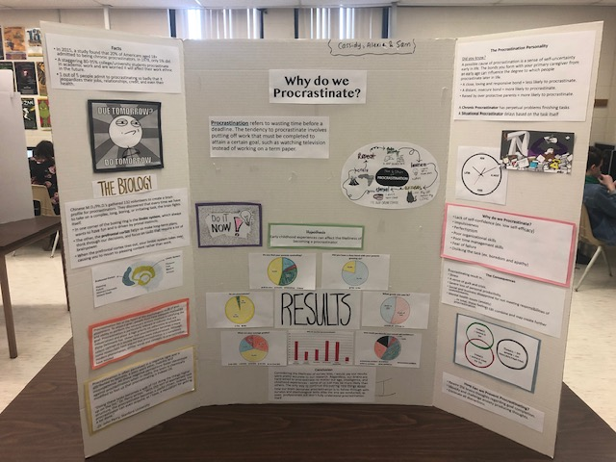
“Why Do We Procrastinate?”
Alexie Savoy Write Up
While doing my project, I’ve learned many things. Our hypothesis was that procrastination was caused by laziness and was also caused by the way you were raised by your parents. By all the research and testing, it had little to do with laziness but very much to do with the way you were raised and even the bond you had with your parents. The biology and parts of the brain responsible for procrastination are the limbic system, which always wants to have fun, pleasure and fear also ties into that. The prefrontal cortex helps us make long term decisions and helps us focus on tasks that require a lot of brain power. When the prefrontal cortex tires out, the limbic system takes over, causing you to resort and pleasing content rather than work. A possible cause of procrastination is a sense of self-uncertainty early in life. The bonds you form with your parents are also an influence, if you see your parents procrastinate you are most likely going to adapt to that ability. There are chronic procrastinators which always procrastinate during their lives and there is a situational procrastinator which only procrastinate sometimes due to different circumstances. There are many reasons why we procrastinate, lack of self-confidence, perfectionism, poor organizational skills, poor time management skills, fear of failure, disliking the task or just simply not understanding the task. There are many consequences for procrastinators and it can honestly change your life. You can have a lot of stress, sense of guilt and crisis, severe loss of personality, productivity and most importantly, mental health issues. Preventing procrastination can be hard for most people, because it’s like a routine that you do every day or sometimes. Rewiring your brain thoughts regarding goal completion which you can set yourself goals or change your abilities like setting due dates a couple days before your bills or assignments are due. In my opinion we should have done a little bit more testing, because we all know some people lie on surveys which can’t give us accurate results. I, as a situational procrastinator, tried to change my abilities by putting my phone off and away also my television and sat in my room, studied the subject I disliked the most, the then work that was easier I did that last, so I had more motivation. So, my project changed my life in a procrastinating way and it helped me realize that I had to change my abilities.
Cassidy English - Write Up
This psychology project has definitely given me a deeper understanding as to why I constantly feel so inclined to put my urgent work aside - to procrastinate. We began with a hypothesis that our childhood has a huge overall effect on how likely we are to be a procrastinator - and also that procrastinating can affect one's grades in school. Through our research we came to find out that how we are raised can be the root of our procrastination issues. Our relationships with our primary caregivers is extremely important - distant, insecure relationships make it more likely you’ll develop procrastination habits, as well as being raised by overprotective parents. This is caused by the self-uncertainty that begins early in life. The likelihood of being a procrastinator declines when we have a close, loving bond with our caregivers. The side effects of procrastination can ultimately ruin many things in our lives - among our mental health, relationships with friends/family members, our taxes and our professional lives. So why do we do these things? There is two reasons - our biology and psychology. Psychology says we procrastinate for various reasons, from low self confidence, fear of failure to bad time management. The biology of the brain basically showed us that procrastination is caused by the constant battle between the prefrontal cortex and the limbic system. Our prefrontal cortex works when we do challenging things and it tires easily, so the limbic system (controls pleasure, reward, arousal, ect.) attempts to takes over. When it succeeds, we are told to do something more amusing like watching tv or scrolling on our phones. Technically our brains are wired to procrastinate, so breaking the chronic habit of procrastination would be extremely challenging. Eliminating distractions, setting due dates ahead of time and creating a specific list of priorities can help, but ultimately it comes down to putting yourself in the right mindset that you have no other option than to get things done. We discovered there are two kinds of procrastinators, chronic and situational. Chronic procrastinators are those who struggle to get all tasks done, no matter their importance. Situational procrastinators do it on different occasions. Finally, we conducted a survey among grade 11 and 12 students here at JMH to challenge our research and hypothesis. We asked six questions related to our childhoods, school marks and mental health. Overall, the response only verified the research we had previously found. In conclusion we found that the only way to continue gathering an understanding of a topic so untold of like procrastination, is through conducting tests alike our survey. I personally feel that we could’ve touched a bit more on one of society's biggest go-to procrastination activity, our cellphones. Also I would’ve liked to do more research on surveys conducted by psychologists themselves. Our project has definitely made me aware that my procrastination issues are not something I will grow out of on my own. I’ve learned many things that I can to do to alter my mindset and find motivation to complete things on time. This project is the ultimate wake up call for me that I must begin to change this habit here and now.

