Individual and Family Dynamics 120

Research Assignment (S.C.O 1.3)
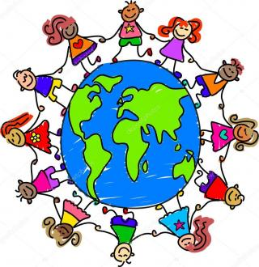

Goal: To research and learn about various customs and traditions that families around the world observe.

Product: You can create a power point presentation, summary or simply use point form to write down a minimum of 5 customs / traditions from various cultures around the world that are DIFFERENT than the customs and traditions of our own families.
If you choose a Power Point presentation, you should have a minimum of 5 slides, attractive in lay-out, use appropriate images to help with understanding and contain very little writing.
If you choose a summary, you should have a minimum of 5 examples and compare how our traditions differ from the traditions of the culture you are using for the comparison. This should be presented in paragraph form.
If you use point form, you should have a minimum of 5 examples and compare how our traditions differ from the traditions of the culture you are using for the comparison. This should be presented in point form.
*****Some examples are wedding traditions, funeral traditions, religious / civic holidays and ceremonies, etc.

