Hello everyone in class 9,

We have made 2 videos for you.

We hope you like them. We are looking forward to working with you.

One video is about our school in Heerde.

One video is about Heerde itself, a beautiful village in the province of Gelderland.

<https://youtu.be/RzkE7fLDeX4>

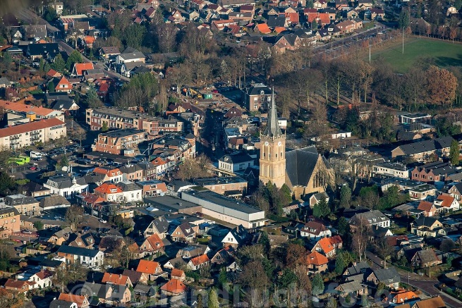

O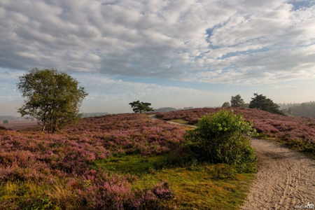

Heerde Surroundings

Heerde is a village in the Netherlands.

Heerde is a municipality in the Dutch province of Gelderland, on the edge of the Veluwe. The municipality has 18.546 km2.

We also have heathland and the Heerder beach, this is where we spend our free time with friends and we have long walks with our dogs.

We are H3B. We're in upper general second education.

We have 24 students in total, 13 boys and 11 girls. The average age is around 14/15 years. Our mentors are Ter Beek who teaches Dutch, and Kistemaker who teaches P.E. Our English teacher is Mrs Schreurs.

Written by: Thom, Rens K, Rens B, Niels W, Maria

*The Noordgouw is in Heerde, that’s a town in the Netherlands. The Netherlands is not only Holland and not only Amsterdam. In our class it’s really cosy and we have nice people. Sometimes it’s really loud in the class, although we don’t have a lot of pupils.*

*Written by :Jelmer, Niels V, Bastiaan, Olaf, Diesel*

