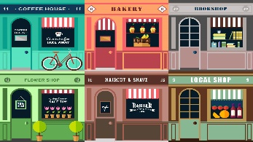
April 13, 2020
English 10
Ms. Courtney

Business Innovation Activity (Part 1)

The ability to think creatively and to be adaptable are skills that are highly regarded in today’s society.

Over the past several weeks we have seen many businesses (in our community, province, country, and around the world) display these very traits.

Instead of simply closing up shop and waiting for the Corona Virus Pandemic to end, numerous companies have stopped doing business as they traditionally would and changed their focus to continue to bring in revenue, be good corporate citizens, or both. (Ex. distilleries producing hand sanitizer and Ralph Lauren making medical masks and gowns)

This is a two-part assignment. For this week’s activity (Part 1), you will research a business that has done just that. This can be a local business or a business that you research through internet/news sites. Then you will answer the following questions in essay format:

- What is the name of the business you’ve researched?

- Where is this business located? (There may be several locations.)

- Who is the owner/operator/CEO of this business?

- What type of business was traditionally carried out by this company?

- What new, innovative way is this company doing business and/or responding to a need in our current society?

- Who is benefiting from this business’ shift of focus? Explain the ways in which they are benefiting.

- What are your personal thoughts regarding this company and its actions?

Your essay requires the following:

- Provide a title for your essay (All important words must be capitalized.)
- Divide your essay into paragraphs and use transition words as you move from one paragraph to the next.
- Include a strong introduction and conclusion.
- Write in complete sentences.
- Use grade-appropriate word choice.
- Provide reference information for your research.
Reference: bing.com

