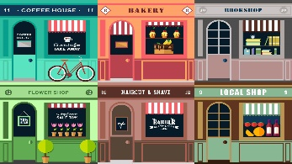
April 20, 2020
English 10
Ms. Courtney

Business Innovation Activity (Part 2)

Last week you were asked to research a business that showed itself to be both creative and adaptable in light of the COVID-19 pandemic and detail the ways in which it changed its business focus to continue to bring in revenue, be a good corporate citizen, or both.

In part 2 of this activity, you will recognize the company’s accomplishments, contributions, innovativeness, etc. by writing a letter to this business.

To do so, you will follow the letter template that I’ve provided. Also, feel free to research business letters online to help you to better understand the layout and the formality with which they are written.

Should you wish, you can actually send this letter to the company. I’m sure they would be honored to hear from you!

Business letters include the following information in the order listed below:

- Sender’s Address

- Date

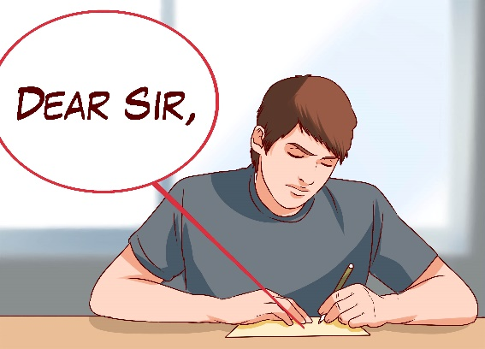
- Receiver’s Address

- Salutation

- Introduction

- Body of Letter

- Conclusion

- Complimentary Close

- Your Handwritten Signature

- Your First and Last Name Typed

Business Letter Template

William Brown (Your First and Last Name)
123 Main Street (Your Street Address)
Miramichi, NB (Your City, Your Province)
E1N 1A2 (Your Country [if going to a business outside of Canada], Your Postal Code)

April 20, 2020 (The Date: Month, Day, Year)

Ms. Sarah Smith (CEO/Owner of Business)
ABC Manufacturing (Business Name)
4005 Maple Street, (Street Address of Business or Head Office)
Fredericton, NB (City, Province or State)
E3C 1R5 (Country [ if outside of Canada], Postal Code or Zip Code)

Dear Ms. Smith: (Salutation)

My name is . . . and I am a tenth grade student at James M. Hill Memorial High School in Miramichi, New Brunswick. I researched your company as part of a home learning English assignment, and I was . . . with the actions your company has recently taken.

What . . . me the most was . . . because (This is where you explain the changes made at the business and how/why you see this as important/impressive, etc. Use notes you’ve made during last week’s assignment. This may require more than one paragraph.)

In conclusion, I _______________________ (Wrap up your letter by stating: you look forward to continuing to follow the company’s innovative progress, continue supporting the business, spreading a good word about the company, hope others follow this company’s example, thanking the company for the work they are doing, etc.)

Sincerely, (Complimentary Close)

(Your Handwritten Signature in Blue or Black Ink)

William Brown (Your First and Last Name Typed)

Your letter requires the following:

- Divide your letter into paragraphs and use transition words as you move from one paragraph to the next.
- Include a strong introduction and conclusion.
- Write in complete sentences.
- Use grade-appropriate word choice.
- Space appropriately and consistently between the various elements of the letter.

Reference: bing.com

