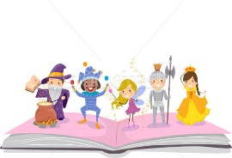
Character Activities
Option 1

When we meet someone for the first time, we pay attention to what they look like, what they say, and what they do. We also listen to what others say about them. This is how we form judgments about people’s character and decide if we want to become friends with them, have that person as a teacher, etc.

In the Venn diagram below, record your main character’s positive traits, negative traits, as well as the traits you would consider to be a bit of both or neutral.

Character’s Name: ___________________________________________________

Positive Traits Negative Traits
Both Positive and Negative
/ Neutral
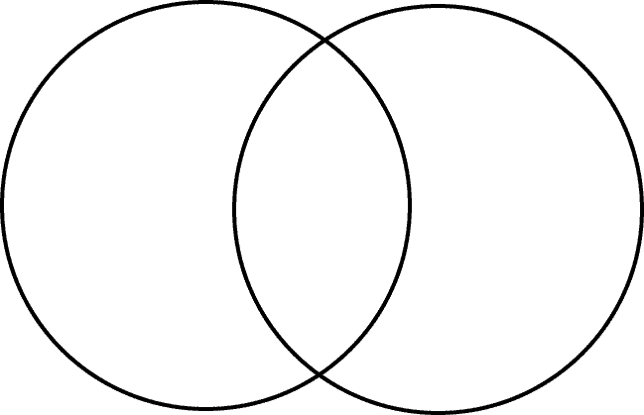

Option 2

In the space below, sketch what you believe the main character in your novel to look like and color/shade your drawing. Include direct quotes from the book to support your assumptions.

Name of Main Character:

Sketch of Main Character:

Direct Quotes from the Novel to Support Your Assumption:

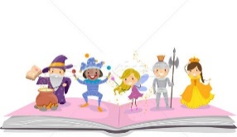
Option 3

Analyze the main character of your novel by completing the chart below.

Name of Main Character: ___________________________________________

Traits to Look For | List Actual Quotes from the Novel | What Character Trait(s) Does This Reveals to the Reader? (Ex. Generous, Ambitious, Cunning, etc.)
What He/She Says:

What He/She Thinks:

What He/She Does:

What Others Think:

Physical Appearance:

Draw your own opinion of this character. Do you like him/her? Explain.

Resources:
youthrelations.org
pintrest.com
bing.com

