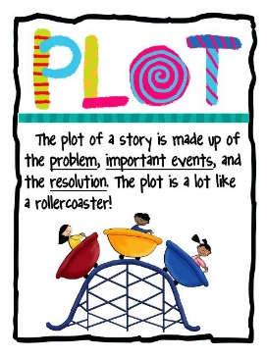
Plot Activities
Option 1

Reflect on the important events that occurred throughout your novel in the
introduction, rising action, climax, falling action, and the conclusion. List these
events along the plot diagram that is provided below. Refer to your PowerPoint
notes to guide you.

Climax

Falling Action

Rising Action

Conclusion

Introduction

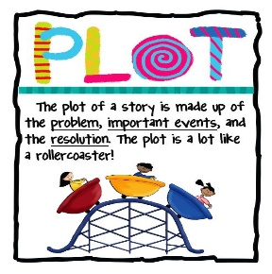
Option 2

In the spaces below, answer the following questions as they pertain to the
plot of your personal novel:

- What important information is revealed during the introduction of your novel? Why do you consider this to be important information?
- What main events are included in the rising action of the novel? Which of these events most impacted the story? Explain.

- What would you consider to be the climax of your novel? Why do you believe this to be so?

- What events occur during the falling action? Were you surprised by any of these events? Why or why not?

- How is the conflict resolved by the end of the novel? Were you satisfied with the conclusion? Why or why not?

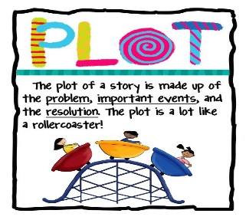
Option 3

Analyze the author’s skill. In the space below, explain the ways in which
he/she was able to use suspense in developing the plot of the story?

Name of Author: _______________________________ Title of Novel: _____________________________

________________________________________________________________________________________________________________________________________________________________________________________________________________________________________________________________________________________________________________________________________________________________________________________________________________________________________________________________________________________________________________________________________________________________________________________________________________________________________________________________________________________________________________________________________________________________________________________________________________________________________________________________________________________________________________________________________________________________________________________________________________________________________________________________________________________________________________________________________________________________________________________________________________________________________________________________________________________________________________________________________________________________________________________________________________________________________________________________________________________________________________________________________________________________________________________________________________________________________________________________________________________________________________________________________________________________________________________________________________________________________________________________________________________________________________________________________________________________________________________________________________________________________________________________________________________________________________________________________________________________________________________________________________________________________________________________________________________
Resources:
readwritethink.org
clipground.com

