How to get into “Microsoft teams”
*Remember, if it asks you to sign in, your User name is this domain:
Ex: AmyWhe000123@student.nbed.nb.ca ; Then your usual password.
(Use your name and code here)

1. Go to the JMH Homepage http://jmh.nbed.nb.ca/
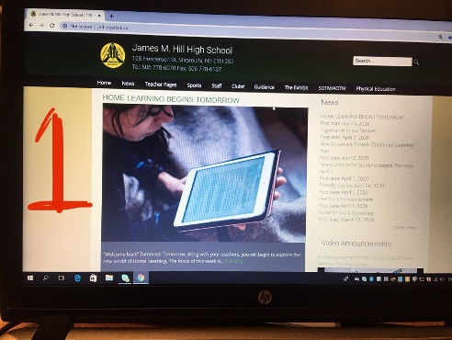

2. Scroll down to the “Quick Links” and go into “Office 365”
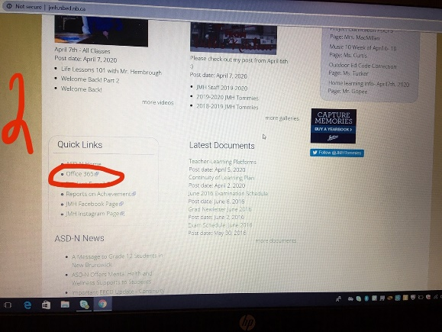

3. Hover your mouse over to the “Teams” Tile and click on it!
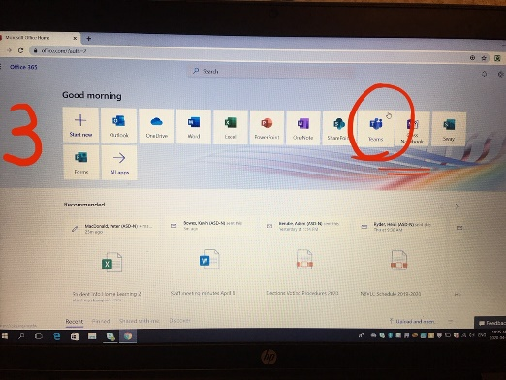

When you sign in the first time, I think this is where it asks for your User name and Password. Remember to use this domain: Ex: AmyWhe000123@student.nbed.nb.ca ; then your usual password.

(Use your name and code here)

