The Dimensions of Wellness

The Dimensions of Wellness - The wellness lifestyle is a coordinated and integrated living pattern that involves seven dimensions: physical, intellectual, emotional, social, spiritual, environmental and occupational. There is a strong interconnection among these dimensions.

1. Physical Dimension – Involves the functional operation of the body. It involves the health-related components of physical fitness – muscular strength, muscular endurance, cardio-respiratory endurance, flexibility and body composition. This also includes medical self-care – getting checkups, tests, etc. Several factors also play a huge part in your physical health: dietary habits, sexual, drinking and drug behaviors.

2. Intellectual Dimension – Addresses the use of the mind. Maintaining an active mind contributes to total well-being. Not restricted to formal education. Curiosity and learning should never stop. Being able to think for yourself about the situations you are faced with.

3. Emotional Dimension – Includes the abilities to laugh, enjoy life, and adjust to change, cope with stress, and maintain intimate relationships. Emotional wellness includes three areas: awareness, acceptance and management. Awareness involves recognizing our feelings as well as others feelings. Acceptance means understanding the normality of human emotion. Management is the ability to control or cope with personal feelings and know how to seek support.

4. Social Dimension - Includes the ability to get along with others, appreciate the uniqueness of others, and feel connected to others. We as humans need to belong and feel wanted. Having good friends, close family members, volunteering, community involvement and trusting relationships are important.

5. Spiritual Dimension – Is the personal search for meaning and direction in life. This is not always synonymous with religion. This is not intended as a religion-specific reference. Spirituality is an all-encompassing term that promotes the principles of harmony, respect, interdependence, and balance. Involves beliefs, principles and values throughout all life’s experiences. There is a strong connection between spirituality and self-esteem because of the internal feelings of self-worth that occur when a sense of hope, purpose and morality is developed. Practicing mindfulness is form of the spiritual dimension.

6. Environmental Dimension – Involves with the preservation of natural resources as well as the protection of plants and wildlife, and the use of our natural resources. Humans have basic biological needs; air, water and food and we need to do what we can to protect those.

7. Occupational Dimension – Is the deriving of personal satisfaction from one’s career/job. It is important that the career you choose is rewarding for you. It’s not always about the money that can be made. The old saying “money can’t buy happiness”.

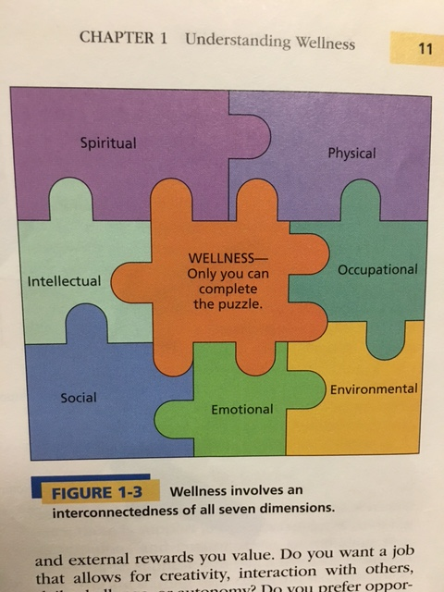

Source: Text A Wellness Way of Life

