The **Elements** of Music

The elements of music are those things that make a style of music sound the way that it does.

***DYNAMICS***

Volume level, and changes in that level. In classical music the terms used to describe dynamic levels are often in Italian.

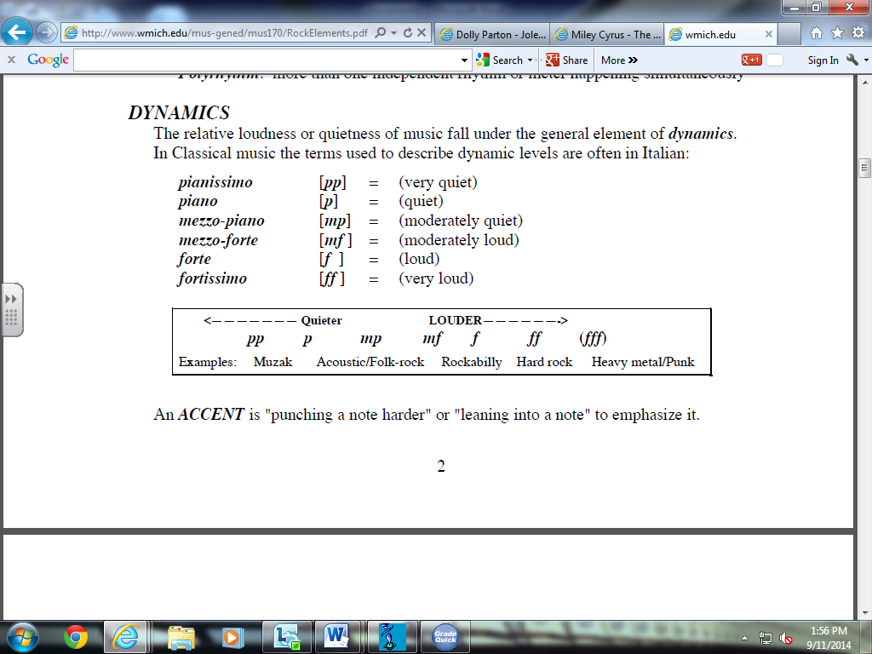

Crescendo (Cresc.) -  Gradually getting louder

Diminuendo (Dim.) -  Gradually getting quieter

***RHYTHM***

Rhythm is the element of time in music. When you tap your foot to music, you are “keeping the beat” or following the rhythmic pulse of the music. There are several important aspects of rhythm:

**DURATION**: how long a sound (or silence) lasts

**TEMPO**: the speed of the BEAT, which can be described by the number of beats per second (or in Classical music by standard Italian terms)

**Allegro** – Fast

**Vivace** – Fast, lively

**Allegretto** – Moderately quick, cheerful

**Moderato** – Moderate

**Andante** – At a moderate walking pace

**Adagio** – Slow

**Lento** – Broad, slow

**Largo** – Very slow

**Grave** – Very slow and serious

**Accelerando (accel.)** – Gradually getting faster

**Rallentando (rall.)** – Gradually getting slower

**Ritardando (rit.)** – Holding back, slower immediately

**Rubato** – At a flexible speed

**Allergando** – broadening out

**Silence/Tacet** – No sound at all

**Pause** ( ) – Hold the note for longer than marked

**A Tempo** – Return to the original speed

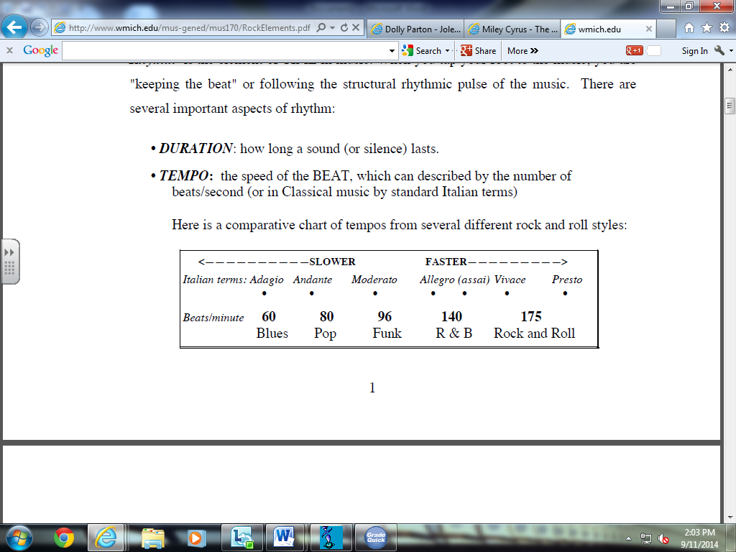

**METER:** When beats are organized into recurring accent patterns, the result is a recognizable *meter*. The most common meters are diagrammed below.

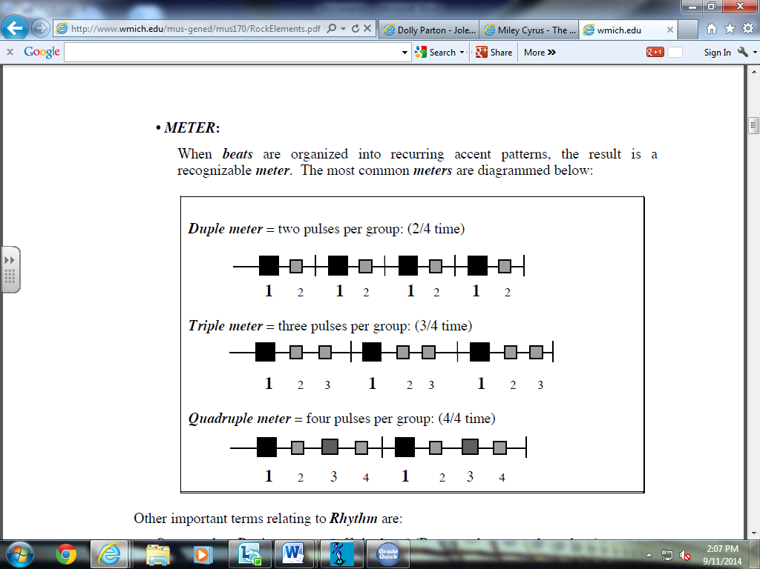

**Conducting Patterns**

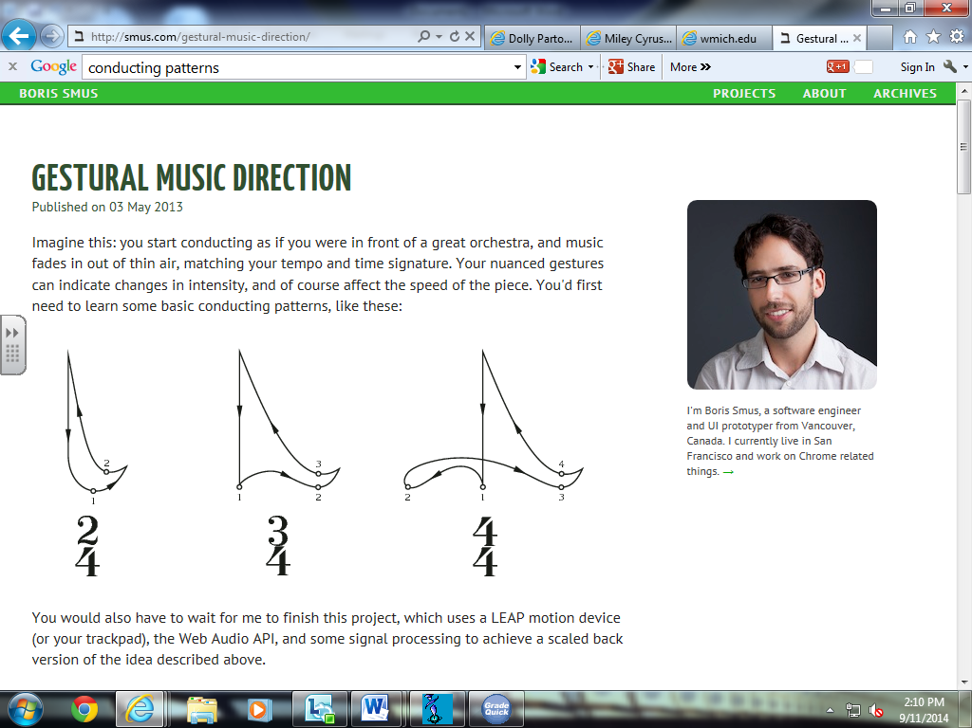

***MELODY***

**Melody** is a succession of sounds (pitches) and silences moving through time. Melodies can be thought of as movement in sound (unison, step, skip, leap). A melody is the part that you might hum to yourself as you remember the song.

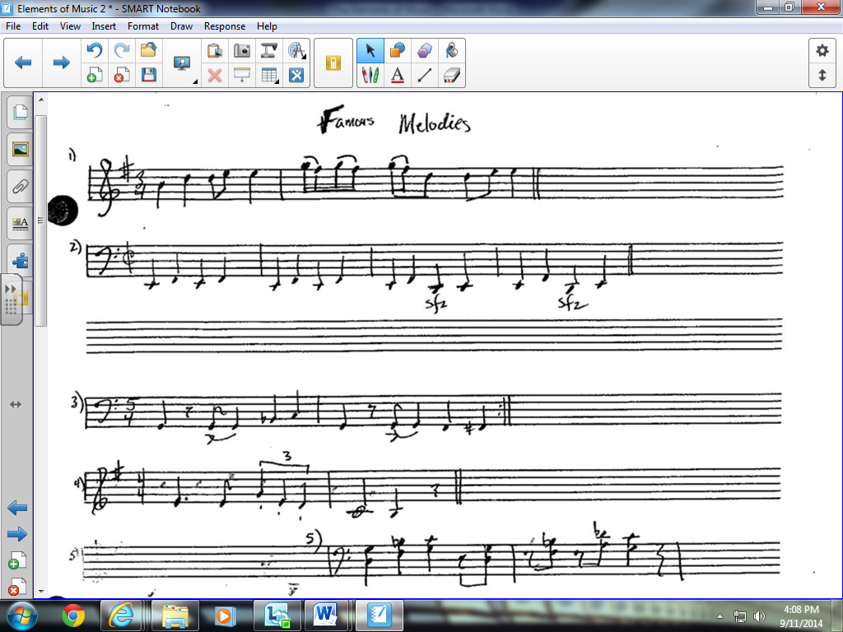

**Step** – next door notes.

**Hop/skip** – notes that are a 3rd apart.

**Leap** – notes that are further apart than a 3rd.

**Scalic** – descending/ascending within a scale.

**Glissando** – Rapid scalic movement on an instrument.

**Ostinato** – Repeated pattern.

**Riff/motif** – A short, repeated pattern, often in the bass part.

***TONE COLOR*** (or **TIMBRE** – pronounced “TAM-BER”)and ARTICULATION

If you play a “c” on the piano and then sing a “c”, you and the piano have obviously produced the same pitch – but why doesn’t your voice sound like the piano? It is because of the laws of physics and musical acoustics. Composers use ***timbre*** much like artists use colors to evoke certain atmospheres on a canvas. So ***instruments*** are sometimes referred to as ***tone colors***.

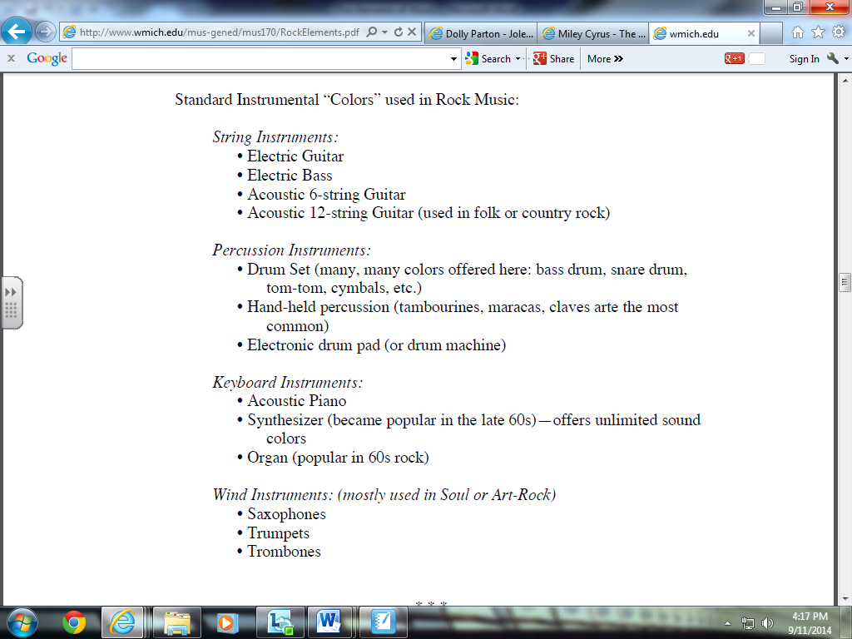

***Timbre*** refers to the way the sound of an instrument can be manipulated or changed.

Example: Strings – Lute, Violin, Viola, Cello, Double Bass, Harp & Guitar

***Timbre*** – **pizzicato** (plucked strings), **arco** (with the bow), **col legno** (with the wood of the bow), **double stopping** (playing two strings at once), **tremolo** – rapid movement upon one string

**Articulation**

**Legato** – Smooth

**Staccato** – Short, detached

**Accent** - Emphasise the note

**Tenuto** – Stress the note

**Voices**

SATB choir:

**Soprano** – Female (Highest)

**Alto** - Female

**Tenor** - Male

**Bass** - Male (Lowest)

**Treble** – Highest children’s voice. Unbroken male voice. Equivalent to adult soprano.

**Baritone** – In between Tenor and Bass male voice.

**Falsetto** – Very high male voice (head voice).

**A Capella** – Unaccompanied singing.

**Melisma** - A tuneful flow of notes sung to a single syllable (Example: chant)

**Backing Vocals/harmonies**

***FORM***

Most musical works are divided into a series of sections, which together make up the form(or “structure”) of the work. Like in poetry, there are some standard forms such as ***binary form* (AB Form); *rondo;* *ternary form* (ABA); *theme and variations*; *twelve bar blues*.** Vocal music often follows the form of its text.

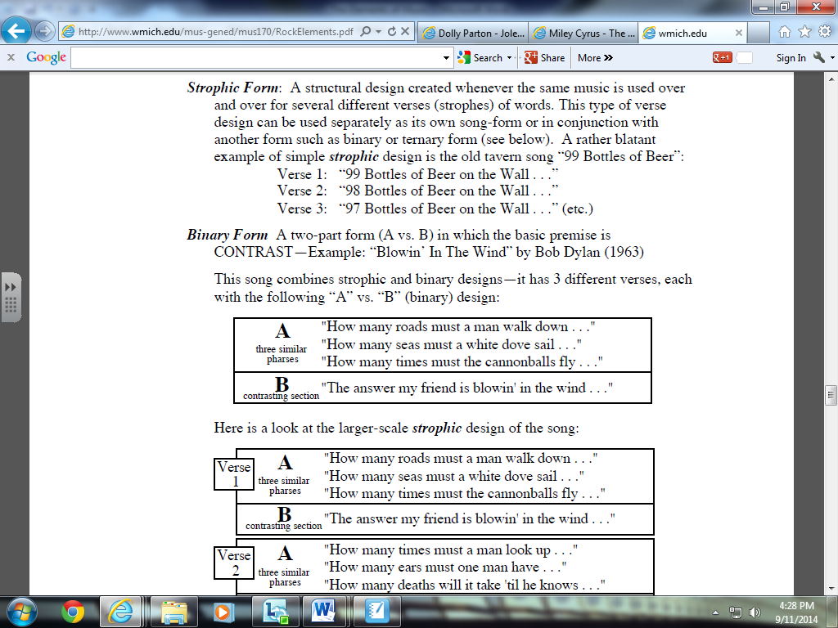

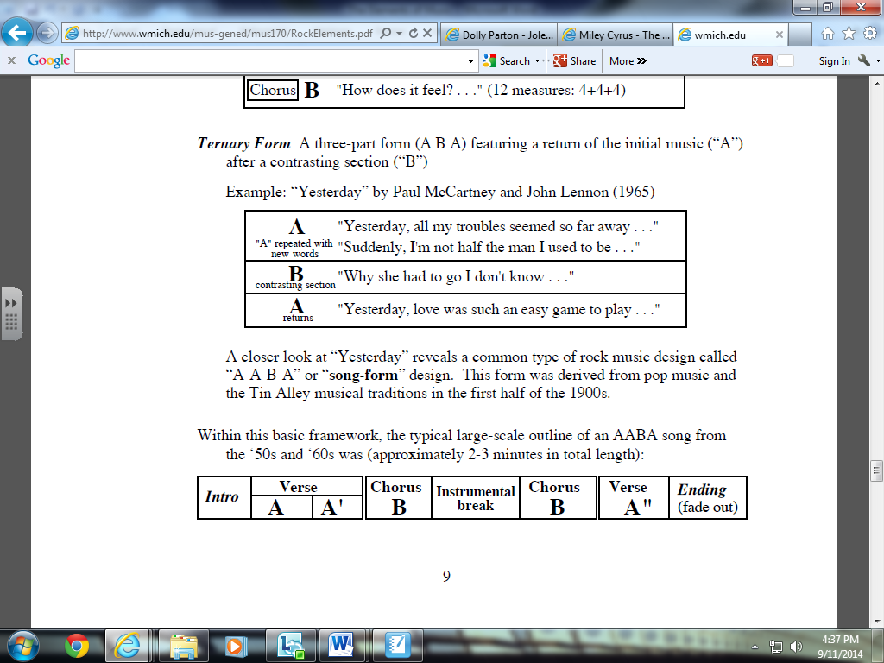

***Other Popular Forms:***

***Rondo*** - A B A C A D A etc.

***Ritornello*** – A section that keeps returning (similar to rondo)

***Ground Bass*** – Repeated bassline.

***Canon*** – Many melodies added one at a time (usually melodies upon a ground bass)

***Theme and Variations*** – Subject followed by set of variations on the subject.

***Aleatoric/indeterminacy/Chance*** – Music in which some or all of the performance is left to chance (Experimental Music).

***Through composed*** – Music that changes regularly throughout (Bohemian Rhapsody – Queen).

***Cyclic*** – repeated music.

***MOOD***

The **mood** is the aspect of the music that is affective. I make you feel an emotion. Researchers in the field use the term “music emotion” or “music mood” to refer to the affective aspects of music. The study and classification of moods or emotion is called Music Psychology.

**Mood List**

**Dark Dramatic Intense Fervent Calm**

**Light Fun Cheerful Tranquil Energetic**

**Fiery Aggressive Relaxed Emotional Angry**

***TEXTURE***

***Monophonic***- A single line of music. A single melody line with no harmonic accompaniment or accompanied by a drone or percussion instrument(s).

***Homophonic*** – Melody with accompaniment. A melody line with a chordal accompaniment.

***Polyphonic***– Two or more melody lines that are heard at the same time. All melody lines are of equal importance.

***Thick***– Many sounds or instruments playing

***Thin*** – Few sounds or instruments playing

***Unison***– More than one person singing the same part

***Solo, two part, three part etc.***

***Duet, Trio, Quartet, Quintet etc.***

***Tutti*** – Everybody playing together

***Descant/Counter Melody*** – A Second Melody playing alongside main melody.