June 1, 2020
English 10
Ms. Courtney

Writing a Fictional Short story – Part 3

Last week you completed the writing stage of your fictional short story. This included all of the following important elements: Introduction, Rising Action, Climax, Falling Action, and Conclusion.

This week, in phase 3 – the editing stage, you will take a closer look at your story and edit it in the following ways:

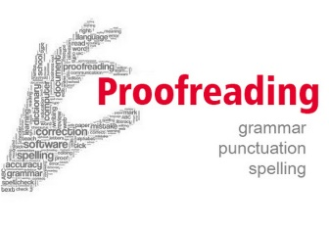

- Check for proper sentence structure.
- Capitalize all proper nouns.
- Ensure that you’ve begun a new paragraph each time you switched topics and that transition words were used to help with flow.
- Pay attention to your word choice and determine if some of your words can be replaced with more descriptive and exciting words. A thesaurus can help with this.
- Ask a family member to read your short story and offer advice/feedback.
- Send your short story to me.

