Why the Magic Happens When You Step Out Of Your Comfort Zone
Tony Fahkry

Not Smooth Sailing
“Move out of your comfort zone. You can only grow if you are willing to feel awkward and uncomfortable when you try something new.” — Brian Tracy
When you take responsibility for your life, serendipitous events unfold and lead you to awaken your inherent wisdom. At this level you must be willing to step out of your comfort zone and meet life with passion and fervor. Here’s an all too common scenario that plays out in people’s lives, illustrating how settling sometimes can lead to apathy and comfort. Life tosses you lemons — well at least that’s what you suspect from where you stand. You may be sick and tired of being in rut. Feeling uninspired — emotionally drained and lacking direction. Don’t despair since you may simply be experiencing an internal shift.
From time to time, you may suffer periods of uncertainty, which on the surface appears as though your world is sinking. You might feel helpless and unable to navigate your journey ahead. Though you can’t quite put your finger on it, something isn’t quite right — you know that part at least. Life seems harder and requires more effort than usual. Everything is a chore. You feel emotional turbulence at the slightest episode when things don’t go according to plan. Rest assured life isn’t always smooth sailing. Seeking refuge in that statement liberates us from having to push against the forces of life.
Like any journey, the intention to reach one’s destination is typically heralded by a goal or a plan, though you may not anticipate the rough waters ahead. That is, you might have to sail your boat in uncharted waters to reach your final destination. Life’s journey is filled with countless lessons, which many fail to concede when embroiled in their drama.
Change Is Debilitating
“Get out of that comfortable rut.” ― The Psychology of Winning

In Paulo Coelho’s acclaimed book The Alchemist, the young shepherd boy Santiago undertakes a quest around to traverse the world in order to find treasure and personal legend. Ultimately as he draws to the end of his journey, he discovers his treasure was right where he started. He recognizes his trek across the world filled him with wisdom and a great deal of knowledge owing to the people he meets along the way. His journey has not been a waste of time, for he has gained much from his experience in search of his treasure.
I wish to remind you that contained within every effort, every step, and every so called failure draws you closer to your treasure — your pot of gold. Nothing is wasted. No effort has been in vain.
There is a rhythm and timing to the universe you must abide with if you wish to realize your potential. With that in mind stepping out of your comfort zone may be paralyzing to some, since there is a level of anxiety associated with uncertainty.
You become accustomed to the familiar that to rock the boat, destabilizes your equilibrium.
Dealing with uncertainty and change can be debilitating in terms of your imposed stress, yet seemingly to live a compelling future requires stepping out of the familiar to reach new horizons.
The image below illustrates how your comfort level is associated with your desire for change. Typically the stronger the desire for change, the more discomfort you feel, as you move toward the unknown.
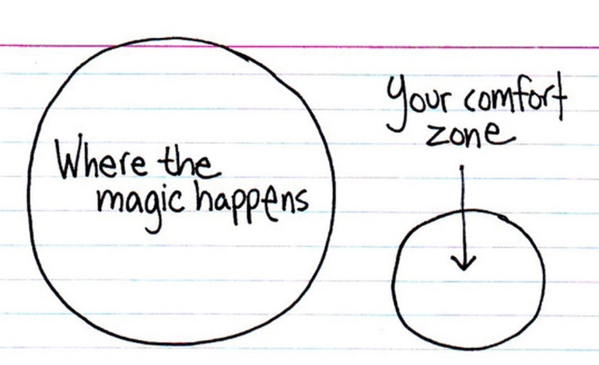
Similarly, depicted in the quote by Lao Tzu is a reminder to allow the process of life to unfold without adding your drama to it: “Life is a series of natural and spontaneous changes. Don’t resist them — that only creates sorrow. Let reality be reality. Let things flow naturally forward in whatever way they like.”
Remember, it is your response to life which is paramount to the level of personal growth you undertake. Most people thrive in ideal situations, although this does not test one’s character.
Your response to life’s uncertainties determines your level of inner growth, especially when the tides are against you.
For example, entrepreneurs require confidence to never give up on their plan or vision, since the economic forces are constantly against them. There must be an inherent self-belief, an unyielding motivation and a desire to prevail.
I encourage you to adopt a similar quality in your pursuit to step out of your comfort zone. Do not rest on your laurels since it is easy — remember, easy is not where the fruit of your success lies.
You must be willing to take risks, whether big or small and gradually move in the direction of your dreams.
Moreover, I invite you to think big and act big, to gain the greater rewards in life.

Success Leaves Clues
“As you move outside of your comfort zone, what was once the unknown and frightening becomes your new normal.” — Robin S. Sharma
Motivational and leadership expert Robin Sharma reminds us of the need to create bigger dreams to strive towards: “If people aren’t laughing at your dreams, your dreams aren’t big enough.”
In the same vein it was David J. Schwartz who wrote the bestselling book The Magic of Thinking Big. He reminds us of the power of our beliefs as a measure of pursuing our dreams with a powerful intensity: “Those who believe they can move mountains, do. Those who believe they can’t, cannot. Belief triggers the power to do.”
Familiarity keeps you safe and oftentimes stuck and stagnant. Most people are quite content to sail through life impervious to their potential. They rather not take risks in the event life does not emerge as they hope for.
Subsequently, their self-esteem takes a hit and they perceive themselves as failures. Yet failure and self-esteem are not inextricably linked.
You are not a failure because your goals fail to materialize the way you hoped for. You may have been unsuccessful in reaching your goal, although you may be drawing closer to success each time, yet unaware of it.
It was Tony Robbins who said: “Success leaves clues.”
Stepping of your comfort requires you to extend your personal boundaries in order to create a fulfilling life. I want you to know those successful people whom you look up to, have pushed past their comfort zone in order to reach their current level of mastery.
They broke through many a glass ceiling to create a new way of life and similarly paved the way for others to follow. That is the inviting aspect of pushing past your comfort zone — you serve as a guidepost for others to follow, by breaking ground in your pursuit.
Yet as alluring as it might seem to push through your comfort zone, you do not want to make it a constant quest.
Integrating your experiences into your life becomes paramount, since it is defined by your learning and inner growth, which becomes the focal point of pushing past your comfort level.

Call To Action

To live a remarkable life, you must take consistent action in spite of your fears and doubts.

