Assignment: Part 1:

**Classical Conditioning Worksheet (Advanced)**

Below are several scenarios depicting classical conditioning. Read each story and try to determine the appropriate classical conditioning terminology.

*Steps for answering each scenario:*

1. *Start by figuring out the NATURALLY OCCURRING, UNLEARNED, BIOLOGICAL stimulus and response connection in each scenario. This will help you identify the unconditioned stimulus and unconditioned response (the word unconditioned means "unlearned", aka "naturally occurring").*
2. *Then identify the stimulus that at first has no connection to the story/US&UR. This will be the neutral stimulus. The neutral stimulus always becomes the conditioned stimulus (or some close derivative of it).*
3. *The conditioned response will usually be the same as the unconditioned response (or some close derivative of it). The point of classical conditioning is that a behavior begins as UNCONDITIONED (unlearned) and becomes CONDITIONED (learned).*
4. *Determine if any of the classical conditioning extensions apply (extinction, spontaneous recovery, generalization, etc.).*

**Protect the Sheep!**

****Farmer Joe is getting continually frustrated by wolves attacking and killing his beautiful sheep. Desperate to save his four remaining livestock (Sheepy, Sheeple, Sheepin, and Sheeptastic), Farmer Joe poisons some leftover sheep meat from the last dead carcass and throws it in the field where the wolves devour it. The wolves get sick from the poison and from that point forward leave the sheep alone. Interestingly, they also avoid all of the other animals on the farm – the pigs, goats, and most importantly, the cats.

1. What is the unconditioned stimulus?
2. What is the unconditioned response?
3. What is the neutral stimulus that becomes the conditioned stimulus?
4. What is the conditioned response?
5. What extension is occurring? Explain.

**Don’t Study in Bed**

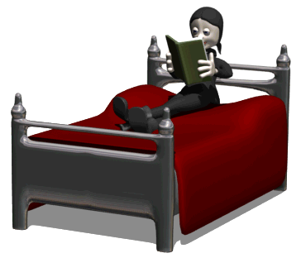Latisha is a dedicated student and as soon as she gets home during the winter she likes to snuggle up in bed and start working on her AP Psychology homework. Because AP Psych is such a stimulating subject, Latisha’s mind begins racing with excitement and wonder as soon as she cracks open her textbook. She’s been noticing lately, though, that when she gets in bed at night and tries to fall asleep, her mind starts racing and she keeps staying awake. So sometimes she goes and sleeps on the couch instead where her mind settles down.

1. What is the unconditioned stimulus?
2. What is the unconditioned response?
3. What is the neutral stimulus that becomes the conditioned stimulus?
4. What is the conditioned response?
5. What extension is occurring? Explain.

**You Smell Hot ;)**

****Xiong loves his girlfriend, Clarice, dearly. Just seeing her drives Xiong wild with attraction and lust. Sometimes Clarice wears Pure Poison by Dior perfume and Xiong starts becoming attracted to the scent. Unfortunately, Xiong later finds out Clarice cheated on him with several members of the choir club, and they break up. A month later, Xiong passes another girl in the hallway wearing the same perfume and the scent slightly rekindles his old feelings.

1. What is the unconditioned stimulus?
2. What is the unconditioned response?
3. What is the neutral stimulus that becomes the conditioned stimulus?
4. What is the conditioned response?
5. What extension is occurring? Explain.

**Cat-fusing**

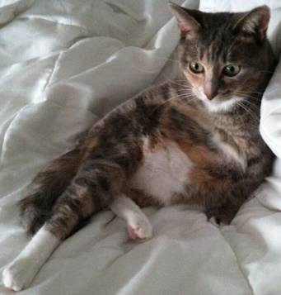Gretta is a beautiful cat with silver, black, and peach streaks in her soft fur. She has glorious white whiskers, ears with tufts of hair sprouting out of them, and a big saggy belly from eating so many snacks during the parties Mr. Oksiuta has with her. She is truly the greatest cat in the history of western civilization. Mr. Oksiuta decides to once again experiment on his precious little furball. Gretta has a very sensitive belly, and whenever Mr. Oksiuta forcibly rubs it, she yells in frustration. Because Mr. Oksiuta smiles while he’s rubbing her belly, Gretta begins to yell just from seeing Mr. Oksiuta’s creepy smile. The next day, Mr. Oksiuta smiles at Gretta while also snapping his fingers at her. Soon enough, Gretta starts yelling just from Mr. Oksiuta’s snaps. Gretta has a hard knock life.

1. What is the unconditioned stimulus?
2. What is the unconditioned response?
3. What is the neutral stimulus that becomes the conditioned stimulus?
4. What is the conditioned response?
5. What extension is occurring? Explain.

**The Weather Man Is a Jerk**

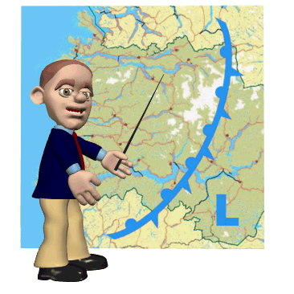Nobody likes crappy weather; when people have to trudge out in the rain and snow they tend to get grumpy. This makes the career of being a weatherman perilously difficult. Often times the weatherman is the one who has to deliver the bad news to your living room about bad impending weather. The local weatherman for Oregon, Paco, often gets booed and heckled on the street by people he doesn’t even know. Tired of being treated this way, Paco quits his job and people stop harassing him.

1. What is the unconditioned stimulus?
2. What is the unconditioned response?
3. What is the neutral stimulus that becomes the conditioned stimulus?
4. What is the conditioned response?
5. What extension is occurring? Explain.

**Hospital Hate**

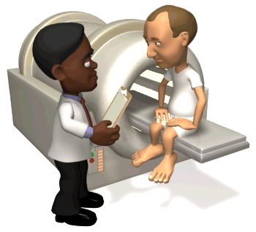Tyrell is suffering from skin cancer and is currently undergoing radiation treatments at the hospital in an attempt to overcome the disease. Tyrell’s physician, Dr. Barlo, is always in the room during these procedures. Unfortunately, the radiation treatments often make Tyrell sick. As the weeks progress, Tyrell sometimes starts to feel sick when he first sees his doctor, before he’s even received any treatment that day. Eventually, Tyrell feels sick seeing anyone in a white lab coat or even when he first walks in the hospital.

1. What is the unconditioned stimulus?
2. What is the unconditioned response?
3. What is the neutral stimulus that becomes the conditioned stimulus?
4. What is the conditioned response?
5. What extension is occurring? Explain.

**The Emma Watson Question**

****Although Emma Watson thought she married the love of her life, Rupert Grint, she was disappointed to find out one day he was leaving her for Miley Cyrus. Emma Watson can’t stop thinking about all of their memories, especially when on their first date they shared their first vanilla milkshake together. At that time, seeing Rupert made Emma feel happy, and she soon felt happy anytime she drank a vanilla milkshake. After being dumped, though, she hates what milkshakes have come to mean to her. So, she adds rat poison to her milkshake to make it taste disgusting, hoping it will fix her problem.

1. What is the unconditioned stimulus?
2. What is the unconditioned response?
3. What is the neutral stimulus that becomes the conditioned stimulus?
4. What is the conditioned response?
5. Is Emma’s plan likely to work? Why or why not?

**OPERANT CONDITIONING WORKSHEET**

**Identify whether each example is Positive Reinforcement, Negative Reinforcement, Positive Punishment, or Negative Punishment.**

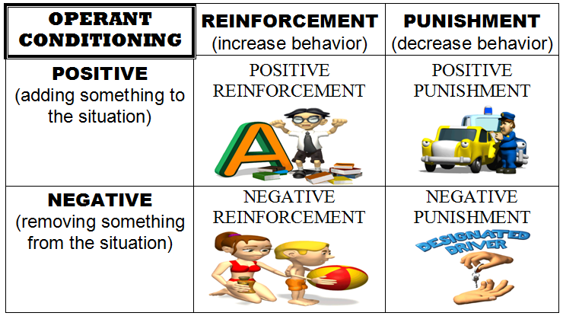

**Keys to Success**

* ***First*: Identify the BEHAVIOR in the situation. Is it increasing (reinforcement) or decreasing (punishment)?**
* ***Second*: In the remaining part of the statement, figure out whether the stimulus is being added (positive) or removed (negative) from the situation to affect the behavior.**

1. Claire receives $5 in allowance for every room she cleans throughout the house.

2. When Kyra texts during class, her teacher takes her cell phone away.

3. If Jackson's dog walks too far ahead of him, Jackson yanks the dog's leash to bring him back.

4. Ariel sprays her cat with water when she jumps on the dinner counter.

5. BJ's mom takes away his grounding after he acts respectfully toward her for two weeks straight.

6. Mr. Oksiuta draws smiley faces on papers when students turn in excellent work.

7. When TJ feels bored, he smokes marijuana.  
8. After Jawon was caught speeding, his parents took away his car keys for three weeks.

9. Dakota was sent to prison for six years after he stole a famous painting from a museum.

10. Dakota lost six years of free time after he stole a famous painting from a museum.

11. After saying the “F” word out loud, Karley has her mouth washed out with soap.

12. Mr. Nedelcoff mocks Brenna when she gets an answer wrong in class.

13. Xu always uses condoms to reduce the risk of contracting STDs.

14. Yanique gets an “A” on an exam that she studied extremely hard for.

15. Quintin receives a speeding ticket after he’s pulled over for not wearing his seat belt.

16. Helen takes an aspirin whenever she starts experiencing a headache.

17. Andrea’s parents buy her a new pair of jeans after she throws a temper tantrum in the mall.

18. Brett is arrested after he is caught video taping a movie in the cinema.

19. When Corey makes a bad decision during a video game, his teammates yell at him for ruining the game.

20. Avery gives her boyfriend a kiss after he brings her flowers on Valentine’s Day.

21. Anna receives an “IE” in the gradebook after she fails to make up her missing test in a timely manner.

22. Finn receives a spanking from his mom after he refuses to eat his vegetables during dinner.

23. When Kyle spends too much time playing video games, his mom unplugs the Xbox and takes the cord.

24. Dan receives a 98% on his curved exam during a college class and his classmates refuse to talk to him.

25. Mr. Oksiuta gives Emma Watson more attention when she wears the dress he bought her.

**Part 2:** Please research two articles (one on classical conditioning and one on operant conditioning)- summarize both articles and discuss the advantages and disadvantages of each. Conclude with you own thoughts about conditioning. (1 page in length)