Monday, May 4, 2020
Ms. Courtney
English 9

Echoes 2020

We are now entering our last phase of the Echoes 2020 Project. In case you don’t have your project information at home with you, I’ve retyped the phase 3 information below.

I would like to have your proposals emailed to me by Monday, May 11th and projects will be due Friday, May 29th.

If you did not participate in the phase 2 portion of the project, but would still like to get involved, please feel free to jump in. The more projects we have to share with our twin school, the better!

Phase 3: Think About the Future

“In this phase, each group creates a final text, poem or piece of art to celebrate 75 years of Liberation. A selection of these contributions will be published in an ‘Echoes 2020 Memorial Book.’ Each participating school will receive a copy of this book.

How might you pass on the echoes from the past into stories of the future? What needs to be done to be able to celebrate 100 years of Liberation in 2045? By whom?”

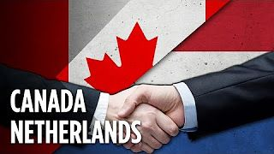

Sources:
Canada – 75 Years of Liberation – the Netherlands Echoes from the Past, Stories for the Future
https://www.bing.com/images/search?view=detailV2&id=32C4E72BC3D61A673B5A7F4A011AA0F6F93BDACD&thid=OIP.14InAHQPjpX_WjjhVQ0SHAEsCo&mediaurl=https%3A%2F%2Fs-media-cache-ak0.pinimg.com%2F736x%2F4c%2F91%2F7f%2F4c917fec5e94c68d78c56be8d9013d5e.jpg&exph=180&expw=320&q=Canadian+and+Netherlands+flags&selectedindex=14&ajaxhist=0&vt=0&eim=1,2,6

