May 11, 2020
English 10
Ms. Courtney

Creating a News Article

Last week, you were asked to think about someone you know who would be an interesting person to interview about how they are dealing with the COVID-19 pandemic and then conduct an interview with that person.

During your interview, you should have collected plenty of information. Now you will use your notes to create a news story about the person you interviewed.

Be sure to include the following information:
- a catchy headline
- a solid lead
- a thorough explanation of the five Ws

*You can even include a picture, if you like!

Before you begin the writing process, create a graphic organizer to help generate information for your news article and to organize the manner in which you will present this information.

Remember to:
- Use complete sentences.
- Paragraph your writing.
- Use transition words as you move from one paragraph to the next.
- Provide a strong introduction and conclusion.

Use the diagram on the following page to help organize the information for your news article. I would love for you to email me your article once you’ve completed it!

How To Organize Information in a News Article

Headline: sums up the report and catches the
reader’s attention.

Lead: introductory paragraph that includes
the most important information
(who, what, when, where, how, why)

Body: elaborates on the lead/most
important information.
(Paragraphs are a mixture of facts,
quotes, and background information.)

Tail/Conclusion:
least important
information

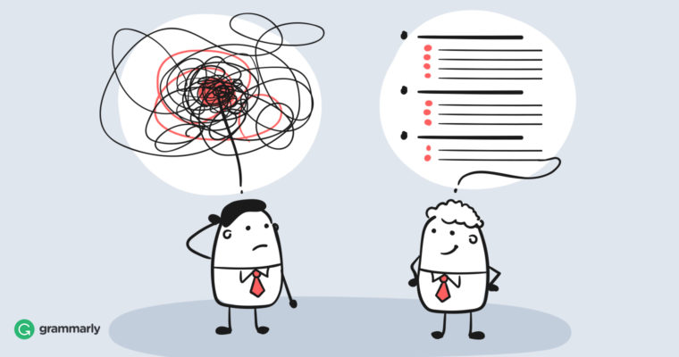

Reference:
https://www.bing.com/images

