Theme Activities

The THEME of the story is the moral, lesson or message that the reader can take away from the reading. Often the theme is confused by the main idea of the story, but the following chart should help you to distinguish between the two:

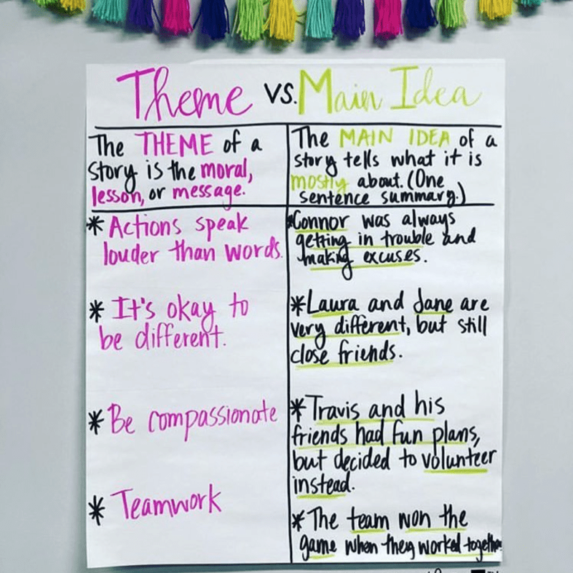

Quite often stories contain several themes. We can determine the themes by asking ourselves the following questions:

- What did the author want me to think about?
- What ideas stay with me after reading the novel?
- What lesson, moral, or message can I take away from this novel?

Reflecting back on your personal novel, think of the themes that are apparent, and then compete one of the activity options below.

Option 1

Following the example provided, think about the themes that are apparent in your novel. In the chart below, list all of these themes and provide supporting details for each.

Themes in my Novel | Supporting Details to Prove these Themes
Example:  Don’t judge a book by its cover. | Suzie’s parents were quick to judge her new boyfriend and they were very hard on him. They felt, because he came from a poor family, that he lacked ambition and he could offer her no future.  They learned they were wrong about Matt when he ran into a burning building, and risked his own life, to save Suzie’s. After that, he sat by her hospital bed around the clock until she was fully recovered. He later went on to become a firefighter and earn a decent and honorable living. Suzie’s parents not only learned to like Matt, they also grew to really admire him.
Option 2

Determine the major theme from your novel. Next, prepare a poster that clearly states your theme. Then create a colored illustration that promotes this theme. Your poster should be eye-catching and people should easily be able to learn the lesson/moral or get the message by viewing your poster.

Resources:
https://www.weareteachers.com/11-tips-for-teaching-about-theme-in-language-arts/
Scholastic.com

