May 18, 2020
English 10
Ms. Courtney

Writing a Fictional Short story

Over the next three weeks we are going to work on creating a fictional short story. This is a story that you make up. To help inspire you and to spur your imagination, I’ve provided a collection of pictures below. You will use any one of these pictures as inspiration for the story you will create. Your short story should be between three and five typed pages (Times New Roman, 12 font, double-spaced).

For this week (Phase 1 – Planning Stage) you will concentrate on mapping out the framework for your story. This includes all of the elements found within a plot diagram: Introduction, Rising Action, Climax, Falling Action, and Conclusion. Your ideas can be listed in point form. (Please refer to the PowerPoint of story elements that we studied during semester one. I’ve uploaded it to my teacher page in the event that you don’t have your copy with you.)

Phase 2 will be the Writing Stage and Phase 3 will be the Editing Stage. I will provide more information regarding these stages over the next couple of weeks. For this week, work on mapping out the important elements/ideas along your plot diagram. Who will be your character(s), where and when will your story take place, and what will happen in your story?

The PLOT is the sequence of events in a story or play. A plot consists of the following five elements:

- Introduction:
This is the beginning of the story where the characters and setting are revealed.

- Rising Action:
This is where the events in the story become complicated and the conflicts in the story occur. These are all the events between the introduction and the climax.

- Climax:
The climax is the point of highest interest and the turning point of the story.

- Falling Action:
It is in the falling action where the events and complications of the story begin to resolve themselves.

- Conclusion:
This is where the events in the story become untangled.

Plot Diagram

Climax

Falling Action

Rising Action

Conclusion

Introduction

*You will most likely need to draw your own plot diagram that will allow more room to chart your information. Use this one as a guide.

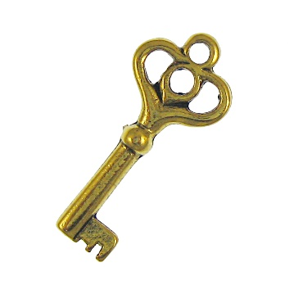
Pictures for Inspiration

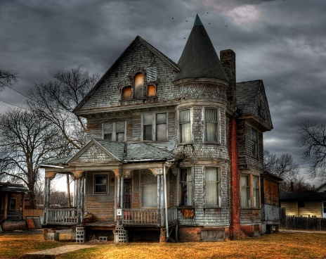

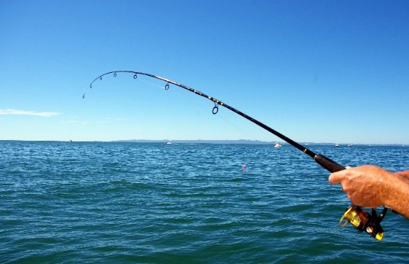

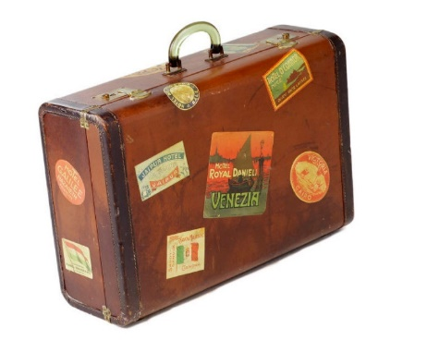

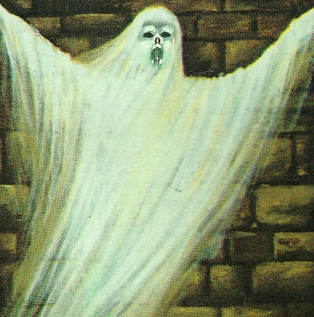

Sources: Bing.com/images

