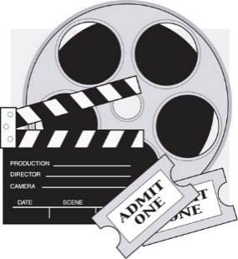
English 9
Ms. Courtney

Movie Review Activity– Part 2

Last week you were asked to view a movie of your own choosing and
take notes on it. You were to look for and document information such
as: the title of the film and the year it came out, the director's name, the
names of the lead actors, the genre, the quality of the cinematography, the tone, music and sound quality, and quality of acting.

You were also to establish your personal opinion of the movie: Was it a great movie?
Was it an okay movie? Was it a terrible movie? What did you like and dislike about this movie?

***************

This week, your assignment is to tell the movie you selected to watch and share your opinion of it through a written movie review.

- To begin your movie review, jot down your thoughts and ideas in point form or use a graphic organizer.

- Next, begin the writing process using the information provided on the following page.

- Once you’ve said everything that you’d like to say about the movie, go back over your review and do the following:
- Check for proper sentence structure.
- Capitalize all proper nouns.
- Ensure that you’ve begun a new paragraph each time you switched topics and that transition words were used to help with flow.
- Pay attention to your word choice and determine if some of your words can be replaced with more descriptive and exciting words. A thesaurus can help with this.
- Ask a family member to read your review and offer advice/feedback.
- Send your review to me.

The following information should guide you through the writing process:

Regardless of how good or how bad a movie may be, it still deserves to be critiqued.

Movie reviews should do the following four things:
- Entertain
- Persuade
- Inform
- Provide an original opinion without giving away too much of the plot

- Start with a compelling fact or opinion on the movie. You want to get the reader hooked immediately.

- Give a clear, well-established opinion early on (Don't leave the reader guessing whether you like the movie or not), then spend the rest of the time "proving" your rating.
Examples:
  - Great Movie: "is the rare movie that succeeds on almost every level, where each character, scene, costume, and joke firing on all cylinders, make a film worth repeated viewings."
  - Bad Movie: "It doesn't matter how much you enjoy kung-fu and karate films: with 47 Ronin, you're better off saving your money, your popcorn, and time."
  - Okay Movie: "I loved the wildly uneven Interstellar far more than I should have, but that doesn't mean it is perfect. Ultimately, the utter awe and spectacle of space swept me through the admittedly heavy-handed plotting and dialogue."

- Move beyond the obvious plot analysis. Plot is just one piece of a movie, and shouldn't dictate your entire review. Other things to focus on include:
  - The title of the film, and the year it came out
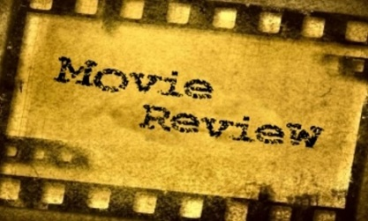
  - The director's name
  - The names of the lead actors
  - The genre
  - Cinematography
  - Tone
  - Music and Sound
  - Acting

- Bring your review full-circle in the ending. Give the review some closure, usually by tying back to your opening fact. Remember, people read reviews to decide whether or not they should watch a movie. End on a sentence that tells them.

https://www.wikihow.com/Write-a-Movie-Review

I’ve provided a couple of movie reviews for you to use as a guide for creating your own:
Example 1

Sample Online Movie Review for “Meet the Parents”
I recently saw “Meet the Parents” and was very pleased with the movie. It is a comedy that depicts what happens when a man is introduced to his girlfriend’s family for the first time. Long story short, this guy ends up getting himself into a world of trouble that he never expected.

This movie is filled with amazing actors who truly make the film. First, Robert De Niro gives a legendary performance in this film and is absolutely hilarious. Ben Stiller as the male lead is his usual funny self. Finally, Owen Wilson is also good for a lot of laughs throughout the film, even though he is playing a supporting role. The casting for this movie is truly perfect, and the actors do not disappoint.

As mentioned, during his first meeting with his girlfriend’s family, Greg (Stiller) gets himself into sticky situations involving family pets, lies, family members, fires, and even sporting games. The problems he faces will have you in stitches. Additionally, you won’t be able to help getting so into the movie, and you’ll be on the edge of your seat waiting to see what will happen in the end.

One of the best things about this movie is that it’s so relatable. We all have those awkward moments (many of them having to do with our love lives) that make us cringe. Regardless of your embarrassing situation, Greg has probably gotten into something worse. You can’t help but laugh hysterically at his expense.

Finally, I love how in this film, just when everything seems to finally be going right, can turn around in an instant. Without giving too much away, there are so many times where you think that Greg is finally going to make a good impression but then ends up messing up all over again, sending you into inevitable fits of laughter.

Overall, this is a great movie with a mix of a ton of laughs and a love story all rolled into one. If you’re looking for a pick-me-up or to laugh hysterically, this is undoubtedly the movie for you.

https://www.wikihow.com/Write-a-Movie-Review
Example 2

Sample Movie Review for “Harry Potter and the Goblet of Fire”
This past weekend, I saw the movie “Harry Potter and the Goblet of Fire.” As part of the popular Harry Potter book and movie series, it was definitely one to remember.

This movie is mainly about a large-scale competition between wizards that takes place at Hogwarts over the course of the school year. Harry has been entered into the contest, which is known as The Triwizard Tournament, and many twists and turns make for quite the adventurous competition. True to Harry Potter form, the characters encounter problems, tragedies, challenges, and mysterious behavior that they are forced to decode.

New characters were introduced in this film, which was an enjoyable aspect and added a new element of intrigue that the previous Harry Potter films did not possess. Furthermore, this installment of the series seemed to follow its literary counterpart the most closely and accurately. Also, this film was a good length: not excessively long but long enough to tell the story. Another great aspect of the film was the special effects, particularly with regard to all of the scenes featuring the dragons.

This movie was also different from the rest because it had more story concerning the characters’ love lives. In one particular scene, there was a dance that all of the tournament contestants were to attend. The characters went to the ball, and it was so much fun to watch. First of all, the scenery of the ball was exquisite, and it was so cool to actually feel like you were there! This was definitely one of the highlights of the movie.

Overall, this was, in my opinion, the best Harry Potter film yet and portrays the fantastical story of wizards and the world of Hogwarts extremely well. With the addition of new characters, the fast-paced nature of the film, and the added romantic aspects, this movie was truly a great one

https://www.wikihow.com/Write-a-Movie-Review
bing.com/images

