Home Learning May 11th – 15th, 2020

Chemical Reactions

Recall what a Chemical Reaction is:
- Change that takes place when two or more substances (reactants) change into one or more new substances (products)
- Based on what occurs in the reaction and what chemicals are involved there are various classifications of chemical reactions.

There are 5 different types of chemical reactions that we are going to study:
- Combustion
- Synthesis
- Decomposition
- Single Replacement
- Double Replacement

Combustion:
The reaction of a substance with oxygen to produce oxides and energy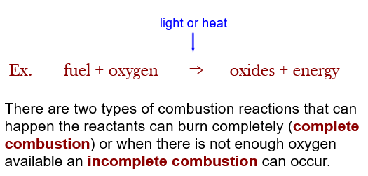
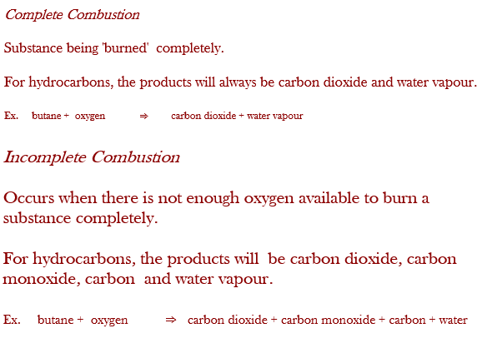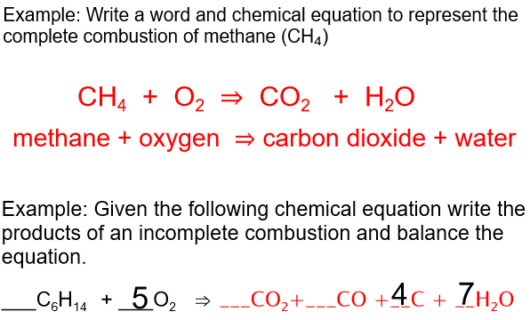
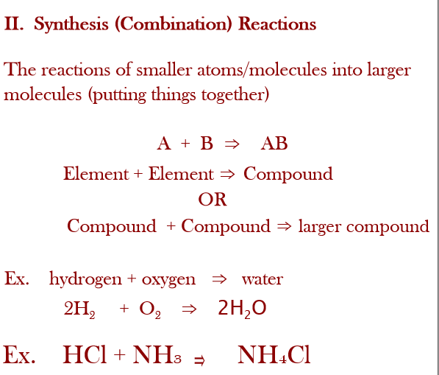

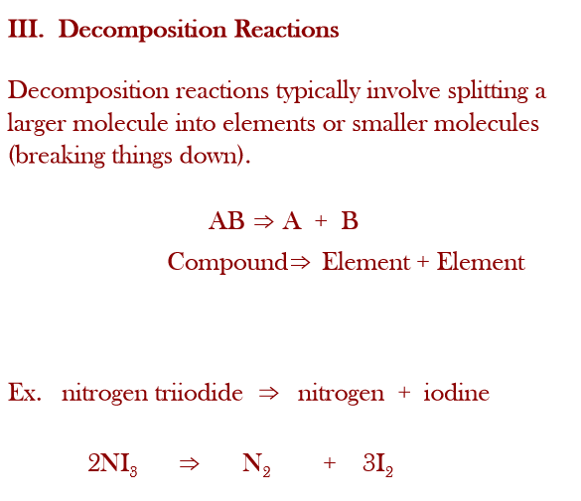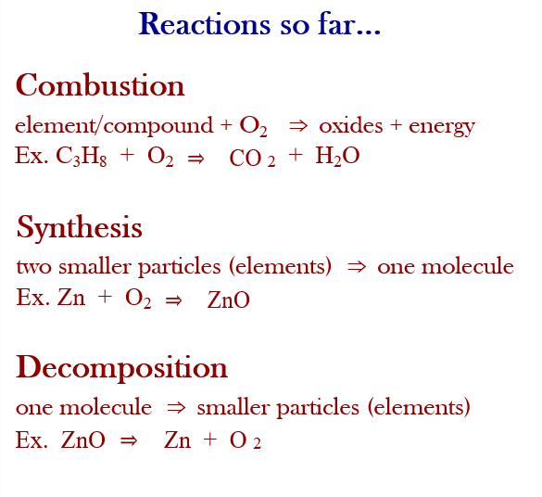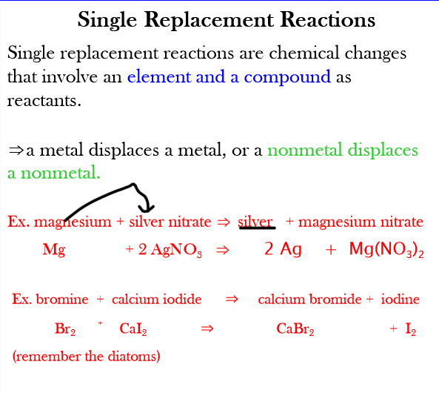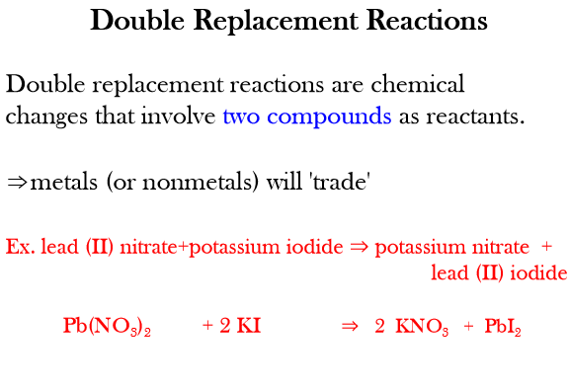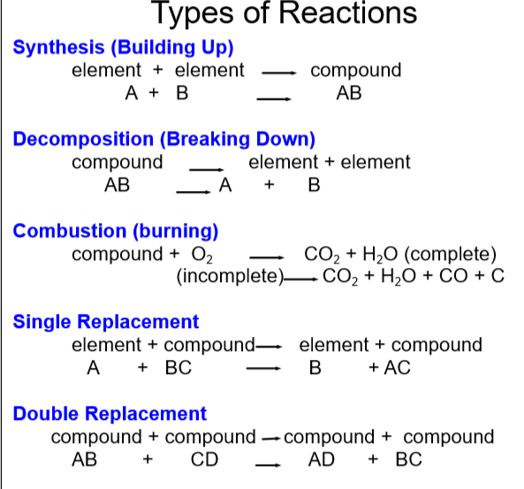

1) NaBr + Ca(OH)₂ à CaBr₂ + NaOH
Type of reaction:

2) NH₃+ H₂SO₄ à (NH₄)₂SO₄
Type of reaction:

3) Pb + H₃PO₄ à H₂ + Pb₃(PO₄)₂
Type of reaction:

4) KClO₃ → KCl + O₂
Type of reaction :

5) KBr + F₂ → KF + Br₂
Type of reaction:

6) Na₃PO₄ + KOH à NaOH + K₃PO₄
Type of reaction:

7) MgCl₂ + Li₂CO₃ à MgCO₃ + LiCl
Type of reaction:

8) CaCO₃ à CaO + CO₂
Type of reaction:

9) C₅H₅ + Fe à Fe(C₅H₅)₂
Type of reaction:

10) SeCl₆ + O₂ à SeO₂ + Cl₂
Type of reaction:

11) C₃H₆O + O₂ à CO₂ + H₂O
Type of reaction:

12) NO₂ à O₂ + N₂
Type of reaction :

13) AlCl₃ + Cs à CsCl + Al
Type of reaction:

