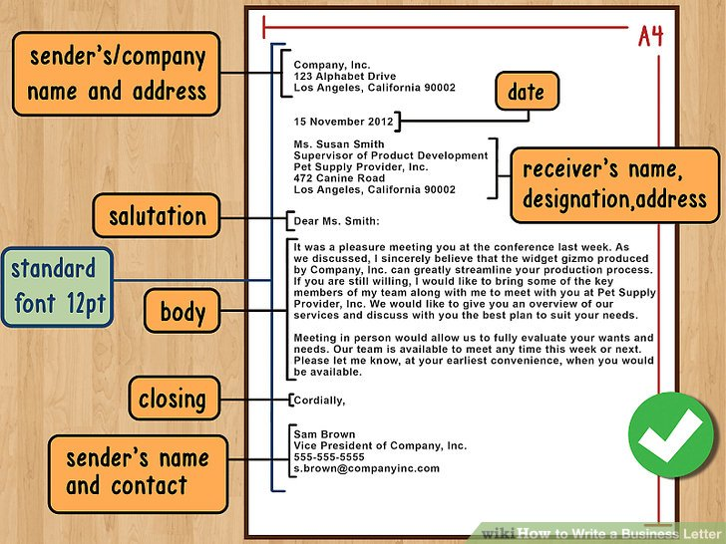

Business Letters

Format
- Business letters should be typed and composed in a common font such as Arial or Times New Roman.

- Employ block paragraphing. This means that you start a new paragraph by hitting "return" twice. Don’t use indenting for block paragraphs.

- Use one-inch margins on all sides.

- An emailed business letter should also be composed in a common font. Don't use script or colors other than black and white in a business email.

- Choose the right kind of paper. The letter should be printed on 8.5” by 11” (known as “letter size”).

- Consider printing the letter on company letterhead. This lends it a more professional air and provides your company's logo and contact information.

Company Information
- List your company name and the company address, with each part of the address written on a different line. If you're self-employed or an independent contractor, add your name either in place of the company name or above it.

- If your company has pre-designed letterhead, you can use this instead of typing out your company and address.

- If you're typing out the address, it should appear either right or left justified at the top of the page, depending on you and your company's preference.

- If you’re sending the letter to an international location, type out the country in capital letters.

Date
- Writing out the full date is the most professional choice. For example, write either "April 1, 2017" or "1 April 2017." This should appear left justified a few lines below the sender's address.

- If you wrote your letter over several days, use the date that you finished the letter.^{[3]}

Recipient's Information
- Write out the recipient's full name, title (if applicable), company name, and address in that order, with each piece of information on a separate line.

- The recipient's information should be left justified a few lines below the date.

- It is best to address the letter to a specific person. This way, an actual person will be able to respond to your letter.

- If you don’t know the name of the person to whom you should send the letter, do a bit of research. Call the company to find out the person’s name and title.

Salutation
- Consider the following options:
- Use "To Whom It May Concern" only if you don't know whom, specifically, you're addressing.
- If you do not know the recipient well, "Dear Sir/Madam" is a safe choice.
- You may also use the recipient's title and last name, e.g. "Dear Dr. Smith."
- If you know the recipient well and enjoy an informal relationship with him or her, you may consider a first-name address, e.g. "Dear Susan."
- If you are unsure of the recipient's gender, simply type the whole name, e.g. "Dear Kris Smith."

- Don't forget a comma after a salutation or a colon after “To Whom It May Concern.”

Tone
- Most business people hate to waste time so the tone of your letter, therefore, should be brief and professional. Make your letter a quick read by diving straight into the matter and keeping your comments brief in the first paragraph. For instance, you can always start with "I am writing you regarding..." and go from there.

  - Don't concern yourself with flowery transitions or lengthy, meandering sentences - your intent should be to communicate what needs to be said as quickly as possible.

  - Be persuasive in your letter. Most likely the purpose of your letter is to persuade your reader to do something: change their mind, correct a problem, send money or take action. Make your case.

Be Courteous
- Even if you are writing with a complaint or concern, you can be courteous.
- For example, a discourteous complaint might read: “I think your sunglasses suck and I am never buying them again.” A courteous complaint might read: “I am disappointed with the construction of your sunglasses, and I plan to take my business elsewhere in the future.”

Conclusion
- In the last paragraph, summarize your points and clearly outline either your planned course of action or what you expect from the recipient.

- Note that the recipient may contact you with questions or concerns, and say thank you for his or her attention to the letter/matter at hand.

Closing
- The closing, like the salutation, is an indicator of respect and formality.

- "Yours sincerely" or "Sincerely" is generally a safe bet; also consider "Cordially," "Respectfully," "Regards" and "Yours Truly."

- Slightly less formal but still professional closings include "All the best,” “Best wishes," "Warm regards," and "Thank you."

- Use a comma after your closing.

Signature
- Leave three or four lines empty for your signature. Sign the letter after you've printed it.

- Blue or black ink is preferred.

Typed Name and Contact Information
- Beneath your signature, type your name, title, phone number, email address and any other applicable means of contact. Give each piece of information its own line.

ABC Inc.
123 Alphabet Drive
Miramichi, New Brunswick E1N 7W7

15 October 2017

Mr. John Doe
Customer Service Representative
Widgets Galore, Inc.
987 Widget Street
Toronto, Ontario M5E 1W2

Dear Mr. Doe:

I am writing you to express concern regarding a recent purchase of widgets that my company has not yet received.

Approximately two weeks ago, on October 1, I ordered a total of 50 widgets for ABC Inc. via the Widgets Galore client webpage. I received an email notification two days later confirming the receipt of payment and the shipment of the widgets. According to your website, shipments should reach their destination within 3-5 business days of being sent, but I have yet to receive the widgets. Do you have any information on what may have happened to delay the shipment or where the shipment is currently?

I have worked with Widgets Galore, Inc. in the past and have the greatest confidence in your products and customer service. We need the shipment of widgets soon; however, and I hoped you might be able to provide me with an idea of when I can expect them. Thank you in advance for any help you might be able to offer.

Sincerely,

Sam Brown
Vice President of ABC Inc.
555-555-5555
s.brown@abcinc.com

