Poetry Terms / Figurative Language

Alliteration: repetition of a beginning consonant sound
Peter Piper picked a peck of pickled peppers.
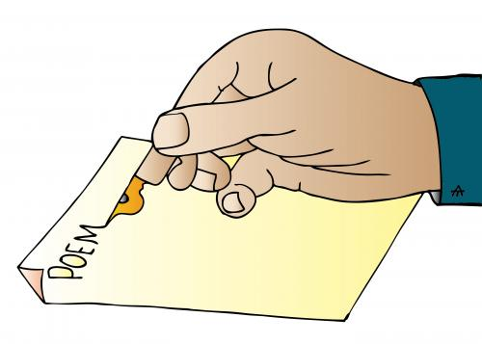
Hyperbole: exaggeration
I am so hungry, I could eat a horse.

Personification: giving human qualities to something that is not human
The trees danced in the wind.

Simile: a comparison that uses “like” or “as”
Her face is like an open book.

Metaphor: a comparison that does not use “like” or “as”
Her face is an open book.

Extended Metaphor: the technique of developing a comparison which has been introduced in the first few lines. It is not limited to one line, but rather present throughout the poem.

Onomatopoeia: a word that sounds like what it means
Crack! Boom! Pop!

Oxymoron: combines contradictory terms
cruel kindness, irregular pattern, serious joke, friendly fire, quiet riot, sweet sorrow, jumbo shrimp

Assonance: repetition of a vowel sound.
The sound of the hound was bound to make me crazy.
You dip your fingers in other lives as in bowls of fragrant liquid . . .

Consonance: repetition of consonant sounds
“Such weight and thick pink bulk.”

Symbolism: something that represents or stands for something else.
A dove is a symbol of peace. A rose is a symbol of love.

Irony: something that is unexpected
You want your brother to get in trouble, but you get in trouble instead.

Imagery: a picture created with rich evocative words. There are several types of imagery: visual (see), aural (hear), tactile (touch), taste, and smell.

Metonymy: when an item is referred to an idea to represent the idea as a whole
The law is at the door. The kettle is boiling.

Apostrophe: a figure of speech consisting of words addressing an inanimate object, abstract idea, or deceased individual as though the object, idea, or person were alive
“O Wild West, thou breath of Autumn . . .” “Ugh, cell phone, why won’t you load my messages?” “Twinkle, twinkle, little star, how I wonder what you are.”

Denotation: the dictionary meaning or the literal meaning of a word

Connotation: the implied meaning, emotional associations of a word. It is meant to produce a personal impression.
- “House” versus “Home”: Both words refer to the structure in which a person lives, yet “home” connotes more warmth and comfort, whereas “house” sounds colder and more distant.
- “Cheap” versus “Affordable”: While both words mean that something does not cost a lot, “cheap” can also connote something that it not well-made or of low value, while “affordable” can refer to a quality item or service that happens to be well-priced.

Allusion: a brief reference to a familiar place, event, or a figure from history, literature, mythology, or bible
He was a real Romeo with the girls. (Alluding to Shakespeare – Romeo and Juliet)
It feels like it’s been raining for forty days and forty nights. (Alluding to the bible – Story of Noah’s Arc)

Mood: the atmosphere of a poem. Writers can create a particular mood or atmosphere by carefully choosing words and rhythms to suit the message of the poem, be it happy, sad, or angry.

Tone: This is similar to mood. It is the way the poem sounds to you, the impression you get of the poet’s ‘voice’. A tone may be angry, bitter, apologetic, sad, reflective, etc. The poem’s rhythm and language create its tone.

Theme: the topic or issue with which the poem is concerned. The theme is usually the idea or attitude that the poet wished to communicate.

Form: the shape of the poem – the arrangement of words into lines and lines into verses or stanzas. This can be determined by the poet’s use of rhyme and rhythm.

Rhyme: When words at the ends of lines finish with the same sound, this is called end rhyme. It is the most common in poetry. When words within the same line have matching rhyme, this is called internal rhyme.

Free Verse: verse that does not have regular rhymes or rhythms or traditional stanza pattern. It will have some informal rhyme and rhythm and its form is likely to be highly structured.

Blank Verse (Iambic Pentameter): unrhymed verses often used in Shakespeare plays. a common meter (rhythmic pattern) in poetry consisting of an unrhymed line with five feet (# of times the pattern occurs) or accents, each foot containing an unstressed and stressed syllable.
Ba\loon
HAMLET: To be, or not to be- that is the question:
Whether ’tis nobler in the mind to suffer
The slings and arrows of outrageous fortune
Or to take arms against a sea of troubles,
And by opposing end them. To die- to sleep-
No more; and by a sleep to say we end
The heartache, and the thousand natural shocks
That flesh is heir to. ‘Tis a consummation
Devoutly to be wish’d. To die- to sleep.
To sleep- perchance to dream: ay, there’s the rub!

Ballad: a story (narrative) told in regular, rhyming, rhythmic stanzas.

