Nancy Lordon Memorial Scholarship
Value: $750.00

Purpose: To assist a deserving female student to pursue further studies or training at a recognized post-secondary institution

Submit to the main office at JMH by May 15th

Recipient will be selected by: Nancy Lordon Memorial Scholarship Committee

Eligibility:
- Must demonstrate leadership skills
- Successful graduation from James M. Hill
- Minimum of two years at this high school
- Applicant must have applied to a post-secondary institution
- Based on need, marks, and participation in school and community

Please feel free to include attachments if additional space is required
Name: _______________________________________________________

Mailing Address: _______________________________________________

_______________________________________ Postal Code: ___________

Phone: _______________________ Email: _________________________

Institution you will attend this September:
_____________________________________________________________

Program/Field of Study for this September:
_____________________________________________________________

List your extracurricular activities, sports, and other involvement at JMH

____________________________________________________________________________________________________________________________________________________________________________________________________________________________________________________________________
_________________________________________________________________

Describe your community and volunteer involvement in the Miramichi area

_________________________________________________________________________________________________________________________________________________________________________________________________________________________________________________________________________________________________________________

Why is it important to you to give back to your community?

_________________________________________________________________________________________________________________________________________________________________________________________________________________________________________________________________________________________________________________
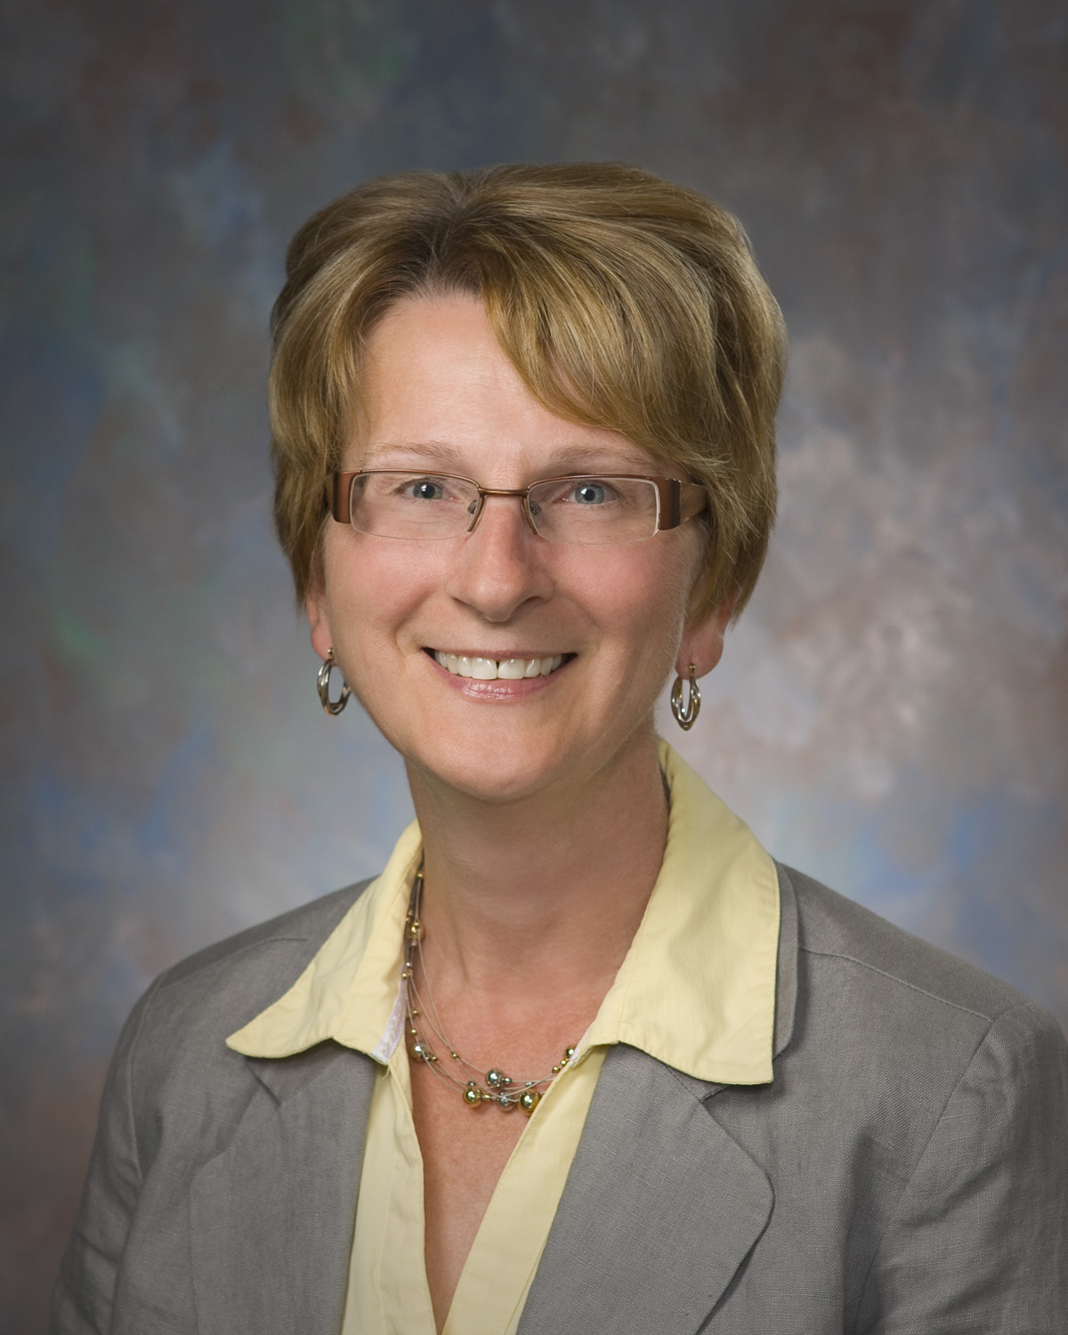
About Nancy Lordon:
Nancy Lordon, was an active community volunteer
and Miramichi’s first female Deputy Mayor. Nancy
dedicated herself to improving life on the river,
especially for the city’s women, youth and those most
in need. Her kind heart and optimistic spirit should be
reflected in the recipient of this scholarship.

